Professional Development Needs Assessment
Spring 2023- Faculty
n=56| Response rate=18%
Approximately 34 % of full-time faculty, 8% of adjunct faculty

Analytical Summary
The most notable aspects of the Spring 2023 Professional Development Needs Assessment for Faculty do not lie in the responses to the questions asked as much as in comparison to previous years. Interest in almost all topics has increased across the board, and faculty who responded used the free response options much less than in previous years.
Demographics
Faculty responses of “Identity not listed” and “Do not wish to answer” for demographic questions have increased by one to two percentage points. This indicates that this survey may need to include more descriptive options in the answer selections. Almost half of the respondents have worked at Compton College for less than five years, and 76% of respondents have been employees for 10 or fewer years.
Barriers to participation
Faculty cite scheduling conflicts as the main barrier to participation at a higher rate than 2021-22 (61%, 57% respectively); “Not interested” (14%) and “Sessions are not relevant” (14%) both increased by around three percentage points. The “Too busy” response remained at 29%. Instances of COVID, predictably, are cited much less frequently (10% as opposed to 26% in 2021-22), yet COVID-related fears of travelling/communing were expressed by 12% of respondents. Awareness of trainings has increased, though, with faculty citing “I was not aware” four percentage points less than last year (6%, 10% respectively).
Hours of participation
Most respondents (31%) attended more than 25 hours of PD in 2022-23 which is about even with last year (32%), however a greater percentage of respondents attended fewer than 15 hours (57%). Those who attended zero hours more than doubled to 17%.
PD topics
Interest in PD topics to improve teaching increased over 10 percentage points across nearly all topics, particularly those related to understanding students’ paths from enrollment to completion/transfer, conflict resolution, identifying and supporting students in crisis, teaching high school or first-year students, DEI for marginalized students, using data for planning and assessment, and understanding policies and procedures.
Respondent Demographics

What is your Guided Pathways Division? What is your ethnicity?
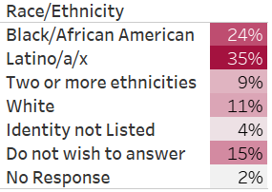
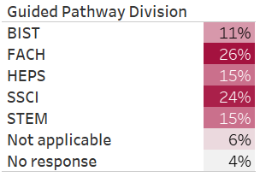

What is your gender? What is your area?
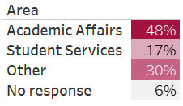
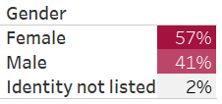

How long have you worked at Compton College?
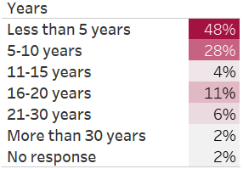

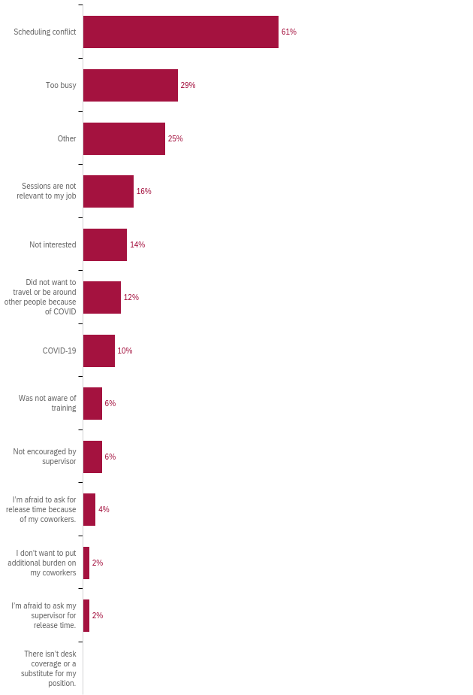
What kept you from participating in professional development activities?

How many professional development hours did you attend in the last year?
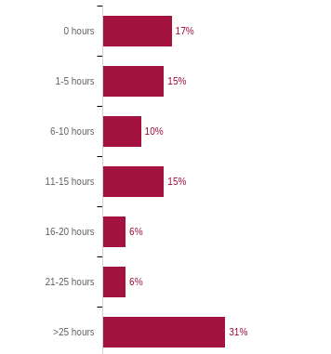

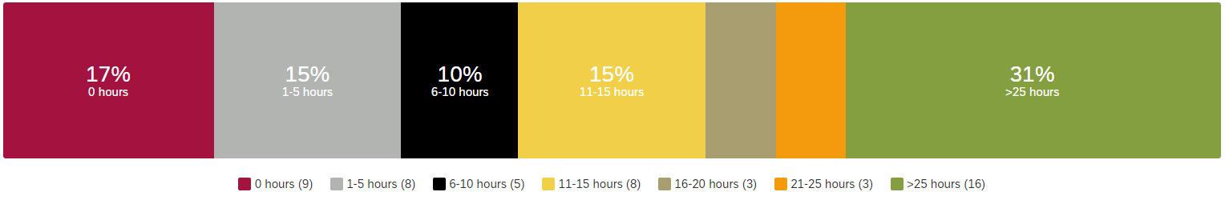

Professional Development for Guided Pathways
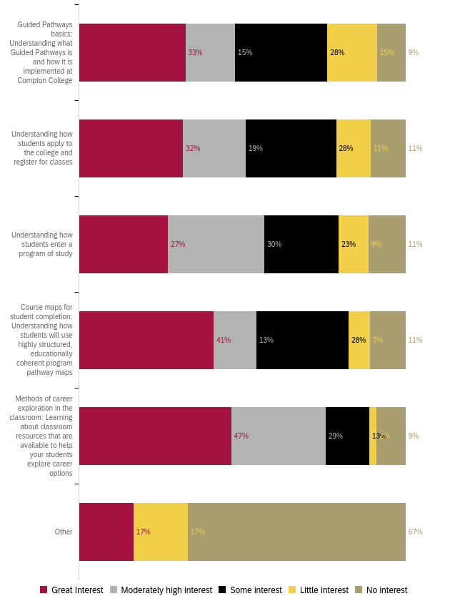
Professional Development to Enhance Teaching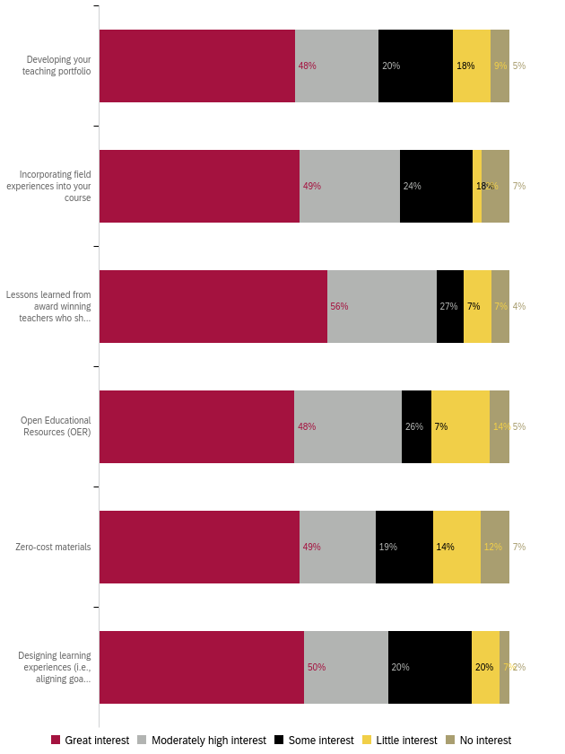
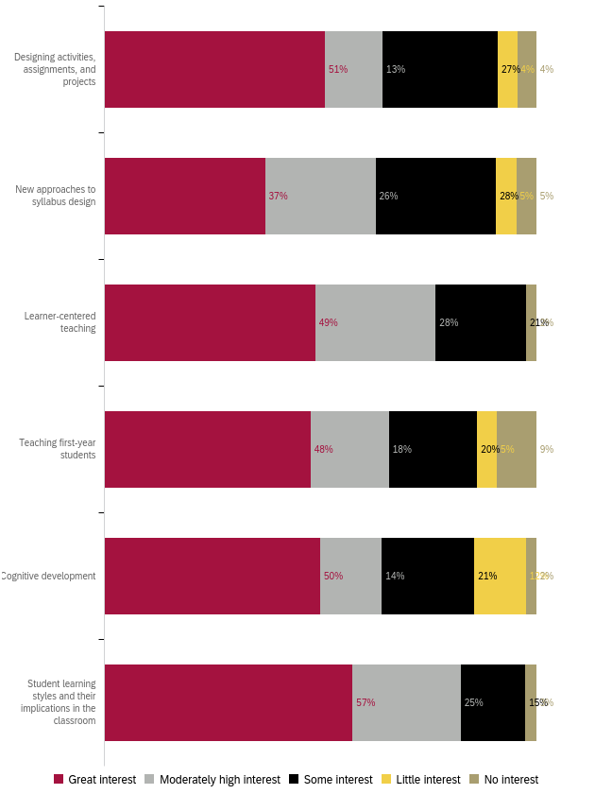
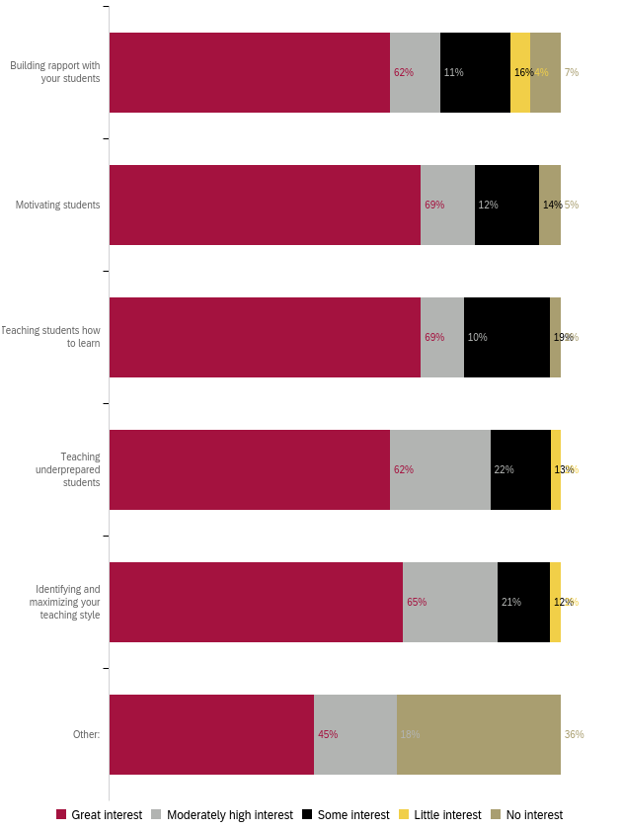
Professional Development for Curriculum Development 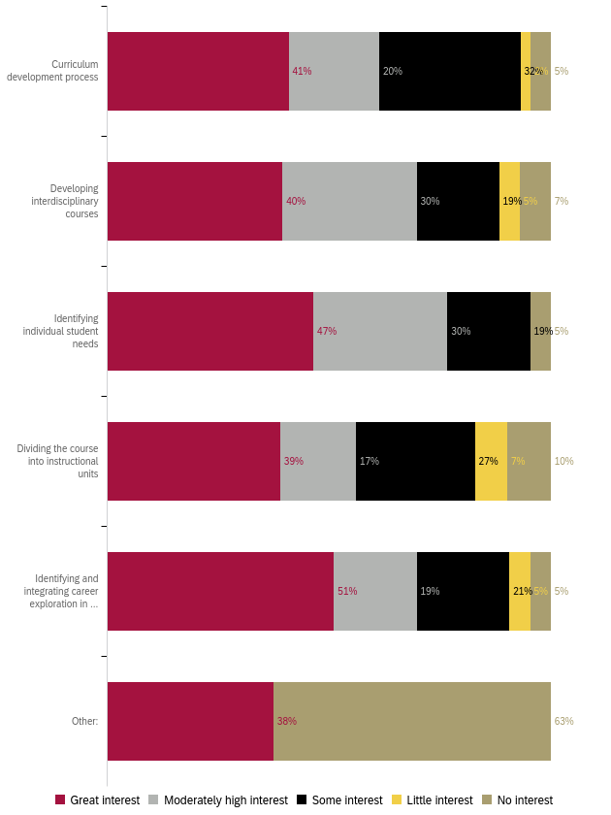
Professional Development for Diversity, Equity, and Inclusion in the Classroom
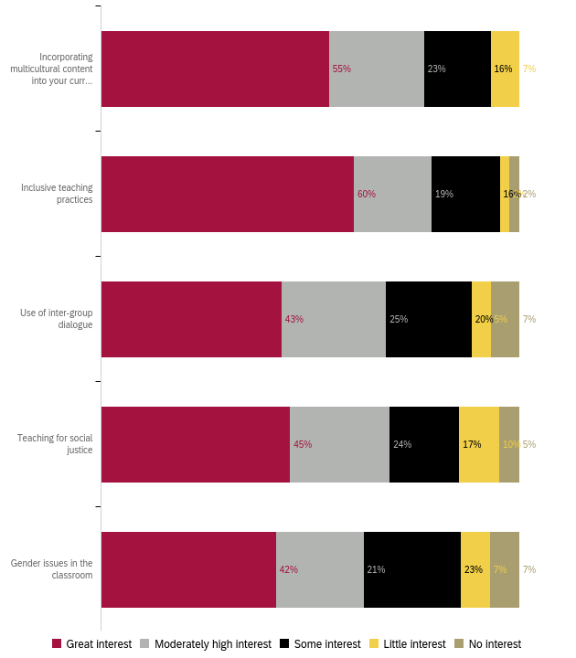

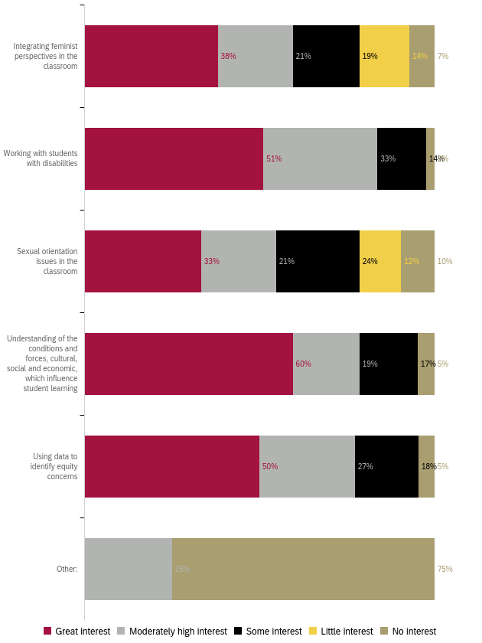

Professional Development to Improve Assessment
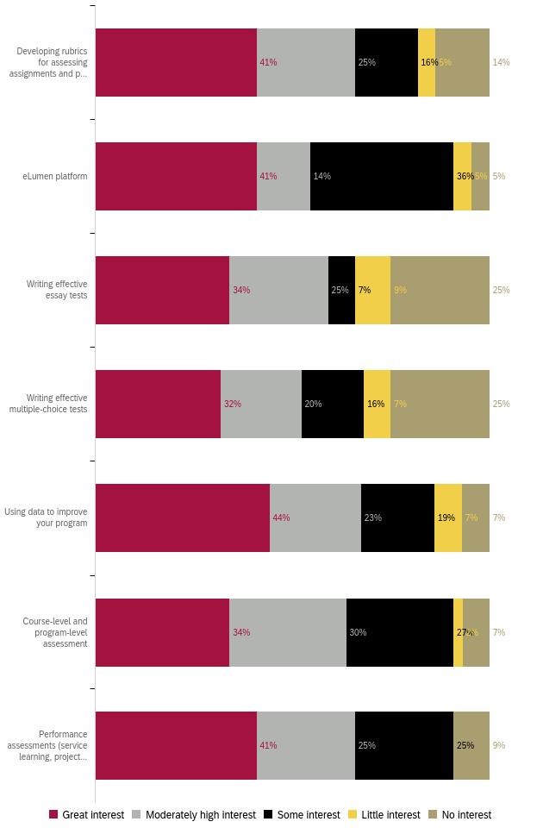

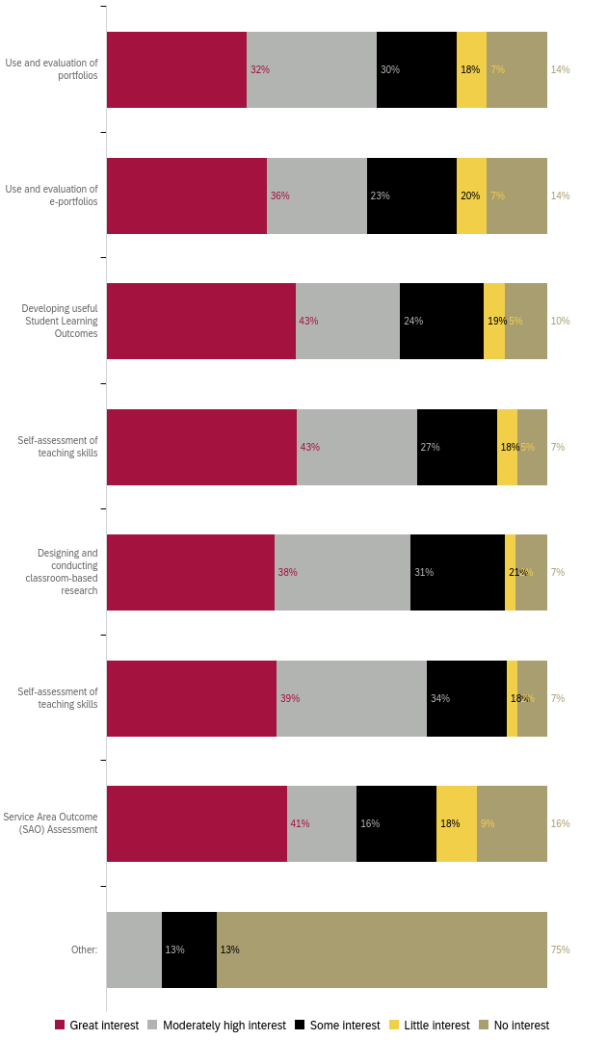

Professional Development for Use of Technology
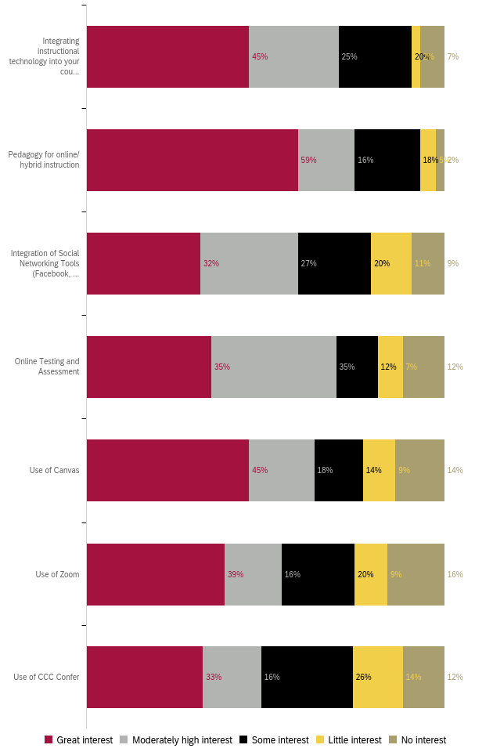
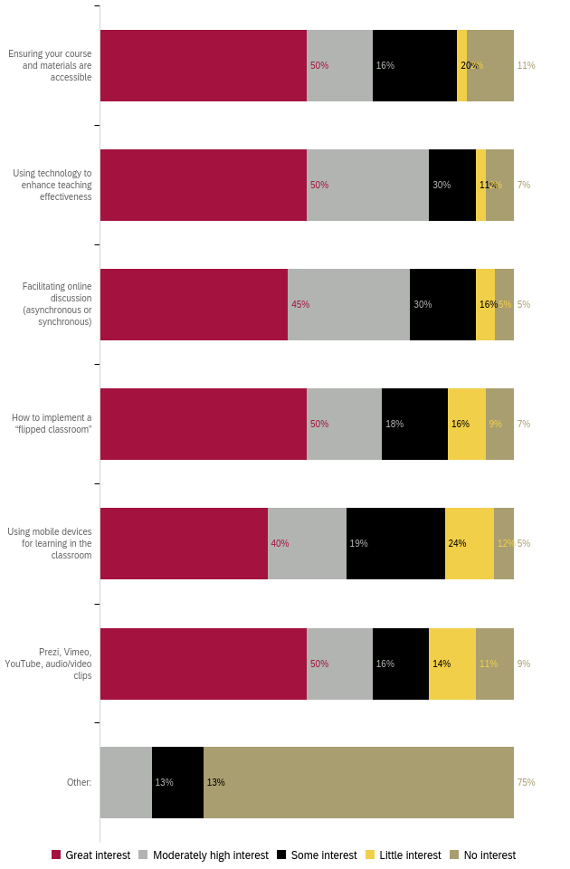
Professional Development for General Use of Technology
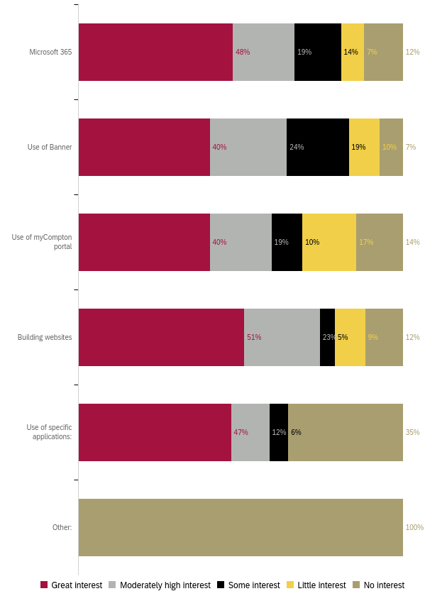

Professional Development for Classroom Management
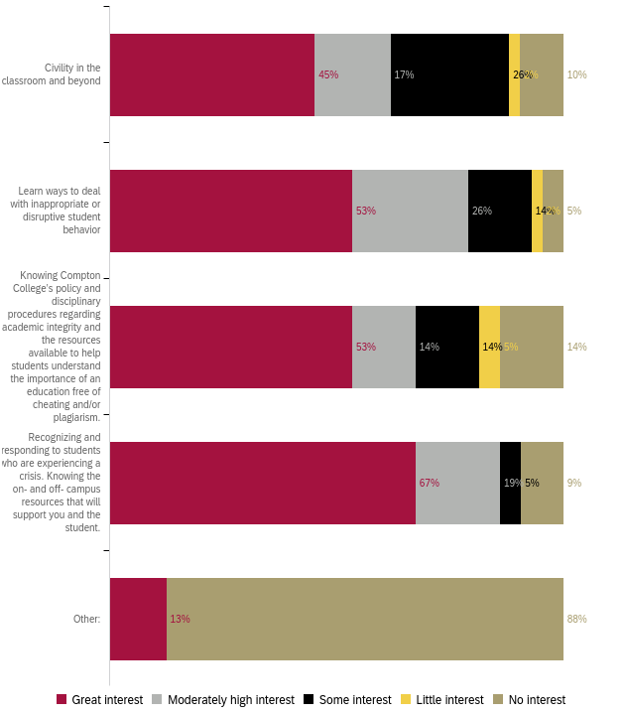

Professional Development for Compton College Policies and Procedures
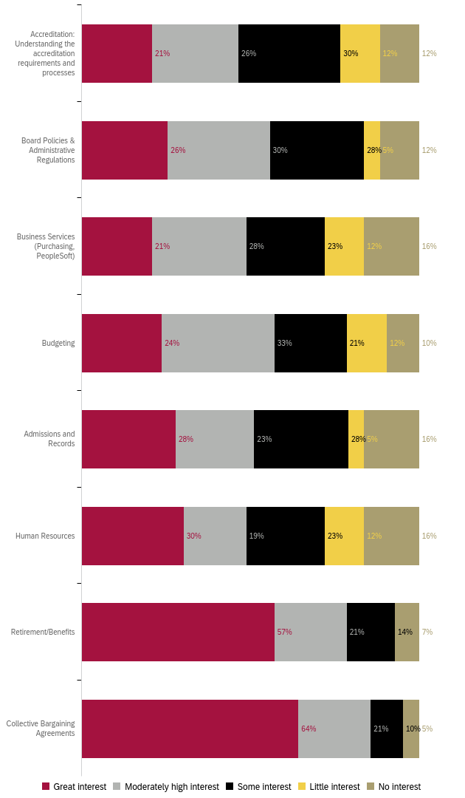
Professional Development for Health and Wellness 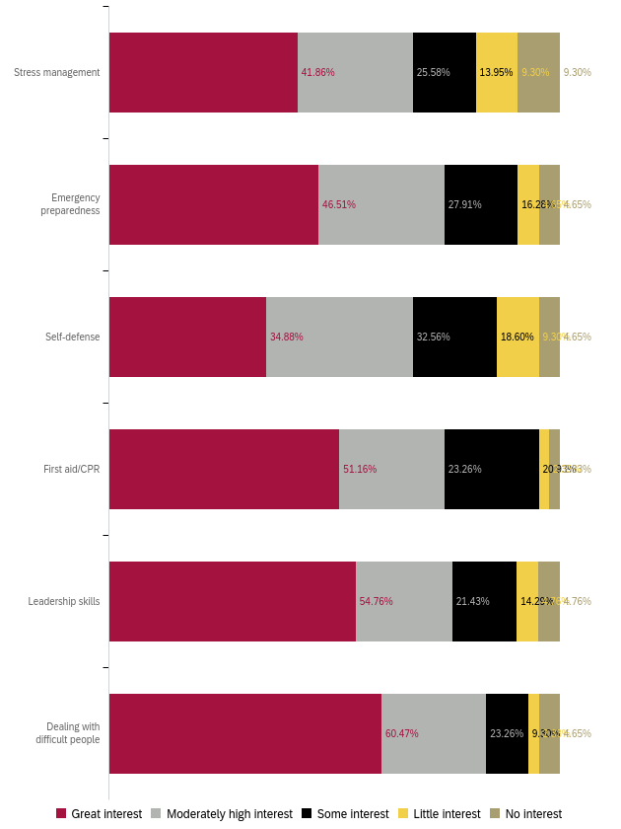

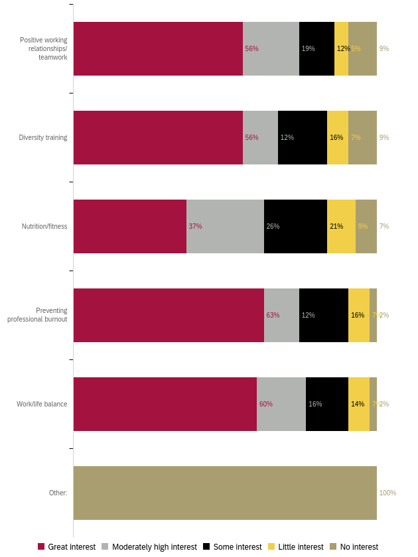
Professional Development to Enhance your Work
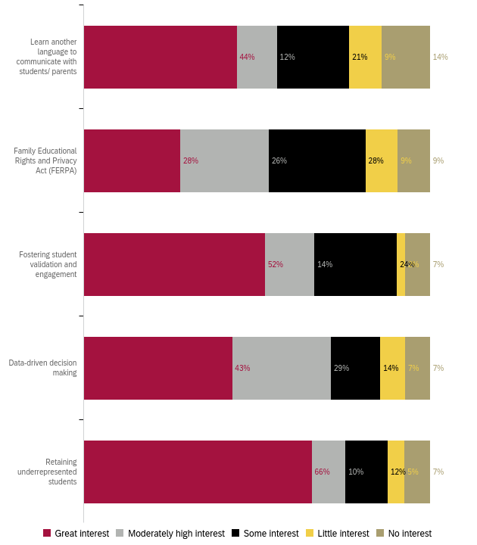

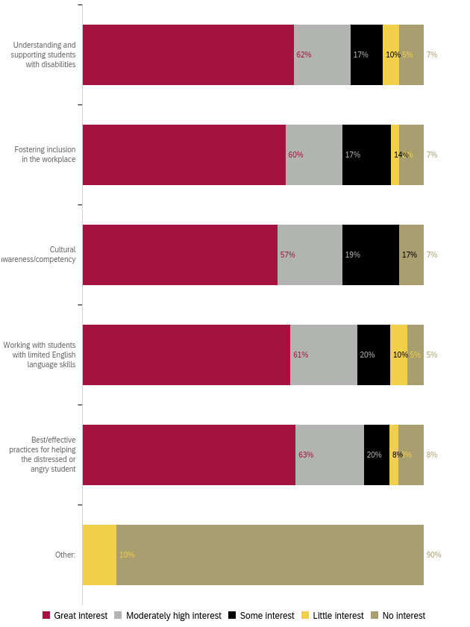
Professional Development for Leadership Skills
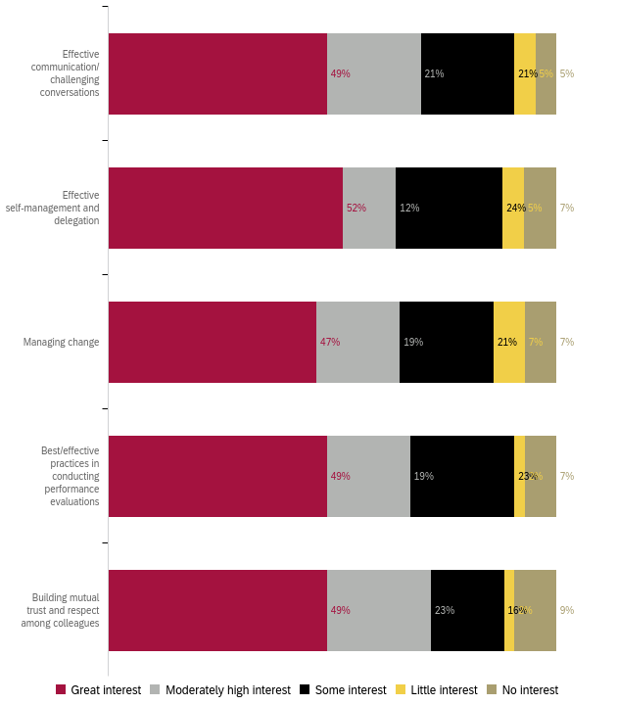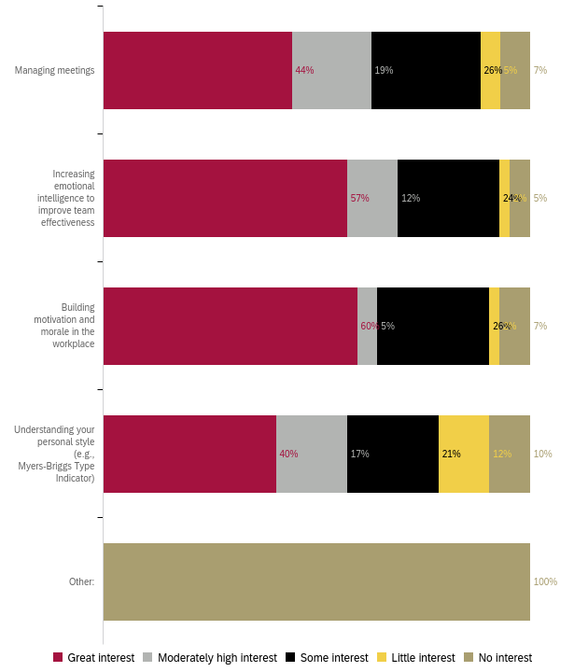

Preferred Professional Development Format 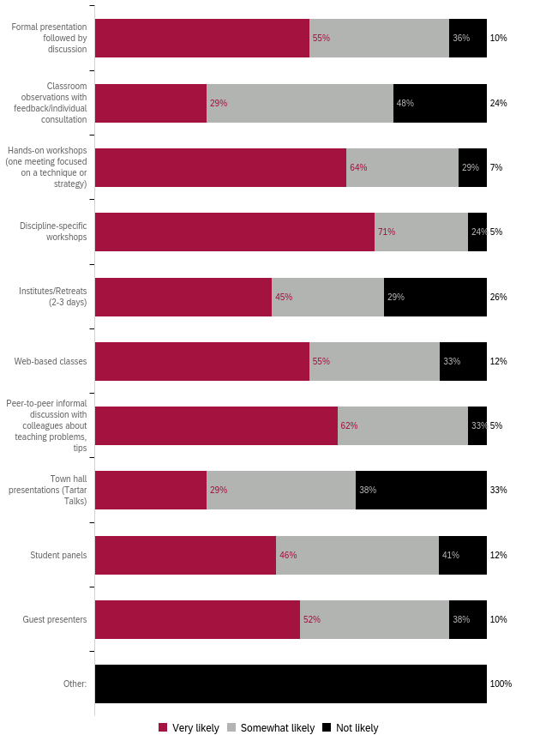

Preferred Format: Ranked 1 (first) to 5 (last)
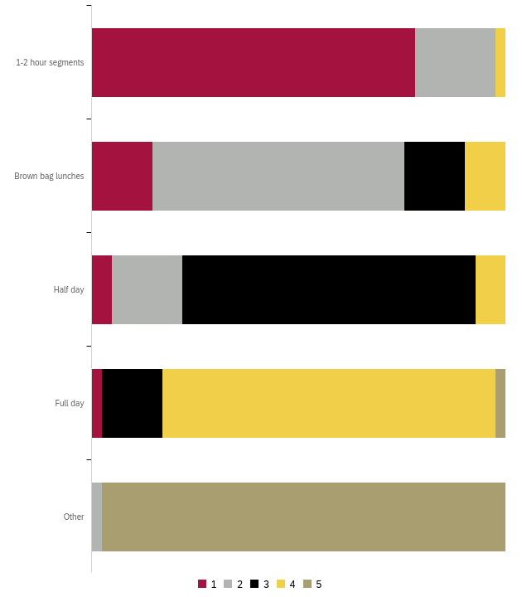
Preferred Day for Training
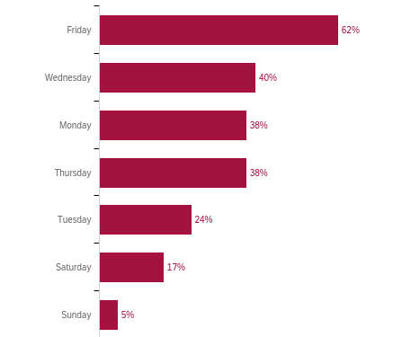

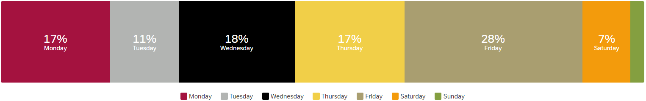

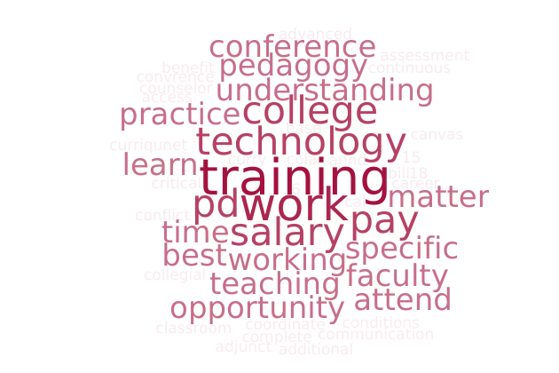
What do you need to enhance your career?

Summary:
The two most common themes from the 28 faculty responses are
- Pay increase to match the cost of living in the Los Angeles area
- Technology trainings
Many expressed an interest in:
- Discipline-specific trainings
- Attending conferences along with office hours for help with the paperwork process
- Pedagogy for high school and Dual Enrollment students
Responses:
- N/A (4)
- attend more conference and maybe PD office can host office hours to help us complete the PPW
- advanced critical assessment- Evidence based practice..
- Trainings in technology, communication, conflict resolution, supporting marginalized students
- Training on High School pedagogy and classroom management.
- To learn the specific needs of this institution in order to help fill the gap and solve the needs of this institution.
- Salary Increase, Benefits, Tuition Reimbursement, Leadership Development, Conference Presentations
- Recognition of work ethic and my dedication to teaching.
- PD opportunities related to my subject matter
- More training on Dual Enrollment pedagogy and working with HS partners. Understanding Course Review, Department Review, and other profressional work on Curriqunet
- More time to be able to do a better quality job. More pay so I don't have to teach as much, so I can dedicated the needed time to quality instead of quantity, trying to pay bills. Not getting COLA for the last 6 years means all faculty took a 15-18% pay cut from our Real Salaries. We DESPERATELY need a raise to make up for the horrendous inflation. We all have bills to pay, not just Dr. Curry, whose salary has more than kept up with inflation. He cannot keep saying there isn't money, where there is ALWAYS money for him. That is hypocritical to say the least and an insult to everyone working at the College. It tells all workers that Dr. Curry work is the only one that is valuable. Then he should do all the jobs at the College by himself if he things his work is the only one that matters.
- More teaching opportunities and higher paying positions would enhance my career.
- More guidance
- More Trainings.
- More Canvas aNnd other online training
- Learn additional skills using technology.
- Effective internet technology
- Discipline-specific offerings are my favorite--almost always very useful.
- Continuous learning on best practices as a counselor at Compton College. Regular updates on information, updates on procedures, policies, and services at Compton College.
- Better work conditions, environment, and collegiality.
- Better understanding of how tenure works at Compton - how to best present myself for tenure.
- Better salary. Compton college is a very underpaid college in cal.
- Better pay.
- Be able to attend convrences.
- As an adjunct faculty, I would like access to a leader (dean, full time faculty, HR, coordinator, etc.) who actually has time to invest in the PD of part time faculty.

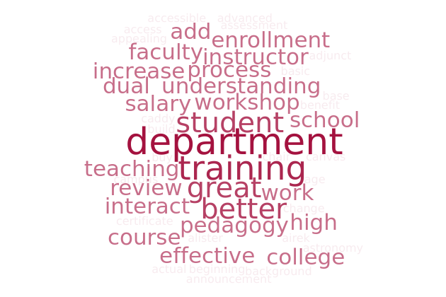
What support or learning opportunity would help you do your job better?

Summary:
Within the 28 responses, the primary themes are
- Higher salary and benefits, including a tuition stipend for advanced degrees
- Pedagogy for high school/Dual Enrollment students:
- Discipline-specific trainings, including nursing
- Training on Canvas to improve classes
- Hands-on workshops
Less prevalent but still important concerns include
- Departmental leadership and guidance
- Leadership development and conferences
- Understanding policies and procedures that affect students
- Understanding tenure
- Accessibility training
Responses:
- N/A (5)
- stipends to complete higher degree, MA or PhD
- More training on Dual Enrollment pedagogy and working with HS partners. Understanding Course Review, Department Review, and other profressional work on Curriqunet
- We have great help with Airek Matthews and Alister Caddy.
- A very motivating remuneration would help adjunct instructors significantly.
- Monthly department meetings: physics and astronomy.
- More Workshops .
- PD on High School Pedagogy and Classroom Management
- Increase rate salary to faculty.
- Cross-training from departments that counseling interacts with to better understand their processes.
- A clear understanding of course expectations and resources, and an actual division chair would great help do my job better.
- advanced critical assessment- Evidence based practice..
- See above.
- Up to date announcements and procedures for each department and service on campus. As a newer employee to Compton College, I am becoming more familiar with all the services, how students access them and changing procedures for each department and how they provide services to students. Finding a way to keep the campus employees up to date would be great to effective serve students with out adding confusion or difficulty to the process (e.g. encouraging websites for each department are up to date and user friendly).
- Hands on workshops
- Self-paced short courses in Canvas that allow to earn certificates. Please work on accessibility for faculty training. Many power points presented in trainings are not legible, are crowded, or are very hard to follow with fonts and background people choose.
- Being new to online teaching (only beginning with the pandemic), I need help on how to better my online courses. I now have basic courses but I could do so much more to humanize them, add more interactive material, and otherwise enhance my courses so they are more appealing and more effective for my students. I also want to diversify my curriculum and include more culturally relevant information to ensure the information is appealing and relevant to my students.
- Collaborating with the other instructors within my department/subject matter.
- Salary Increase, Benefits, Tuition Reimbursement, Leadership Development, Conference Presentations
- Retirement planning, buying properties for our personal economic wellbeing
- support on dual enrollment - how to teach high schoolers vs. college age students the same content. how to manage a high school class. how to build my tenure review portfolio.
- Having someone readily available through email communication so that whenever I have a question I can email them and get a prompt response.
- More nursing focused training and teaching
Is there anything else we should know to help build a robust, useful professional development offering?

Summary:
No real themes emerged from an analysis of the 21 responses, however notable recommendations can be found in the responses below.
Responses:
- No, not now. (12)
- Pedagogy trainings done by other Community College faculty.
- More computer apps to enhance in our teaching.
- Everything is fine. Thank you!
- The union has to do something about faculty underpaid salaries.
- Encourage leadership to make professional development accessible to part-timers during their paid time.
- advanced critical assessment- Evidence based practice..
- Please include a menu of choices for professional development day. This can help to meet our needs. Having 1-2 hour segments to focus on OER workshops, SLOs, AI, developing curriculum, etc. It is frustrating to have to seat half day listening to one or two persons talk. We should have the opportunity to choose activities from variety of offerings in PD day.
- I would love to work one on one with an instructional designer to get pointers for how to improve my Canvas shells.
- Love the newsletters and emails that are sent. LOVE the compassion fatigue. I prefer the Yoga sessions in the mornings.
Appendix A: “Other” Responses
Ethnicity “Other responses:
- Hispano

Non-participation “Other” responses:
- I was participating in various PD activities (4)
- wasn't working at compton
- Do PD outside Compton
- I wasn't employed at Compton College yet
- Currently not teaching there?
- Was informed that I cannot participate in professional development during my work hours because it is not considered direct student contact.
- I did not know i could request a sub to attend PD events.
- N/A

PD for GPD “Other” responses:
- Equitable Teaching Practices, Leading from the Middle, Campus Collaborative PD

PD for Teaching “Other” responses:
- Ethics
- N/A
- Dual Enrollment Teaching Methods
- None
- Teaching Dual Enrollment High School Student: Prada gift and classroom management
- Developing a relationship rich classroom

PD for General Technology “Specific Applications” responses:
- CRM ADVISE
- Word
- Use of Canva
- R, RStudio, Python, Excel

PD for Diversity, Equity, and Inclusion “Other” responses:
- Working with Formerly Incarcerated Students
PD Format “Other” responses:
- 3 hours

“Other” responses listed in Appendix A
“Other” responses listed in Appendix A
“Other” responses listed in Appendix A
“Other” responses listed in Appendix A
“Other” responses listed in Appendix A
“Specific Applications” responses listed in Appendix A
“Other” responses listed in Appendix A

