Professional Development Needs Assessment
Spring 2023
Classified Professionals
n=54 | Response rate=38%

What is your Guided Pathways Division? What is your ethnicity?
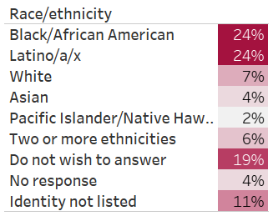
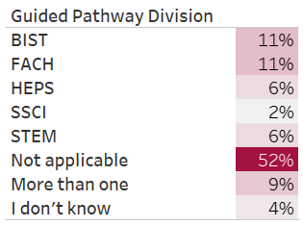

What is your area? What is your gender?
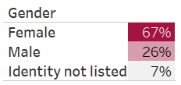
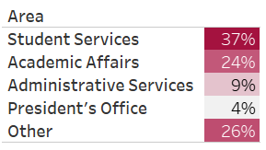

How long have you worked at Compton College?
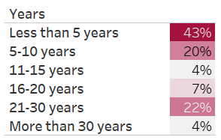

What kept you from participating in professional development activities?
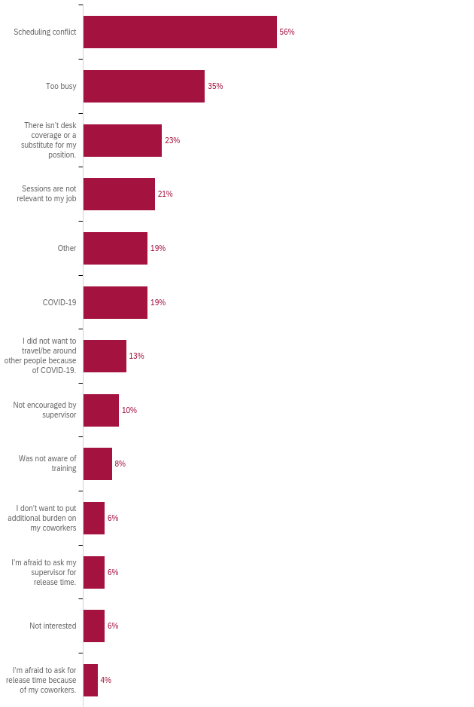

How many professional development hours did you attend in the last year?
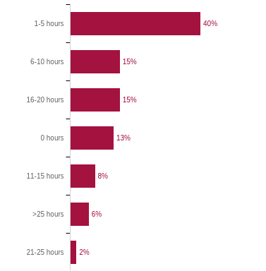

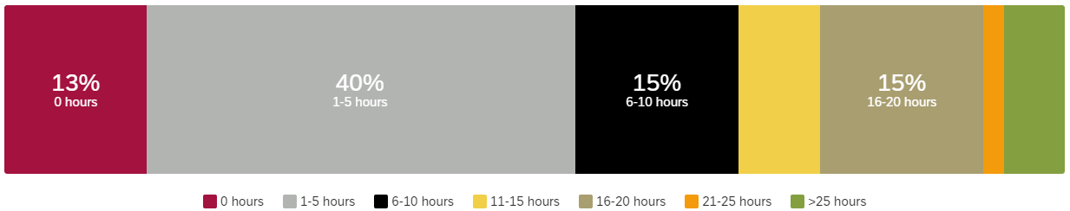

Professional Development for Guided Pathways
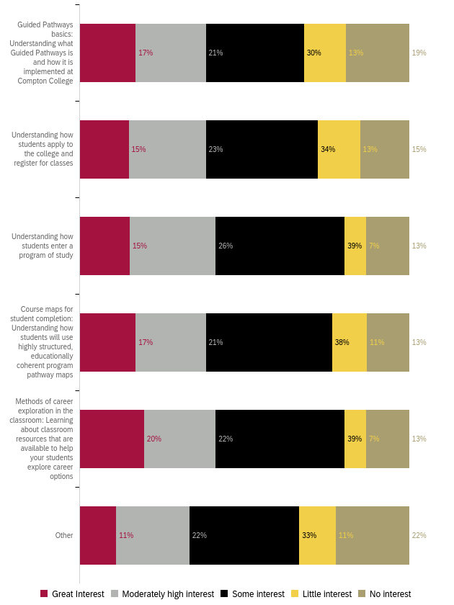
Professional Development for General Use of Technology
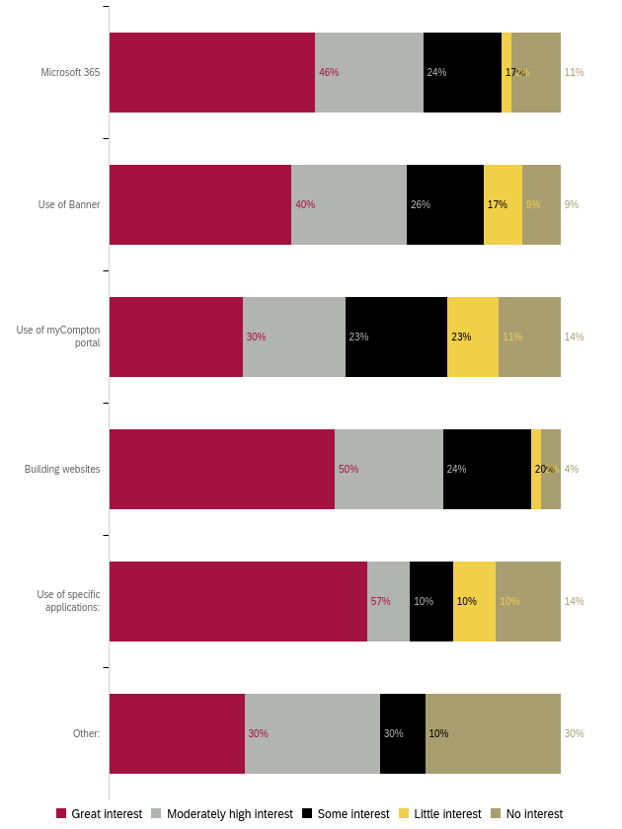

Professional Development for Compton College Policies and Procedures
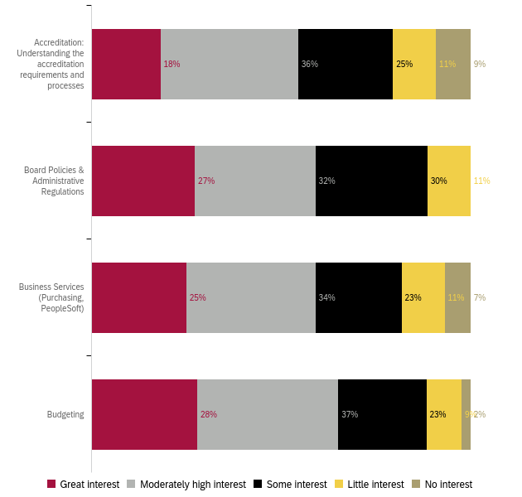
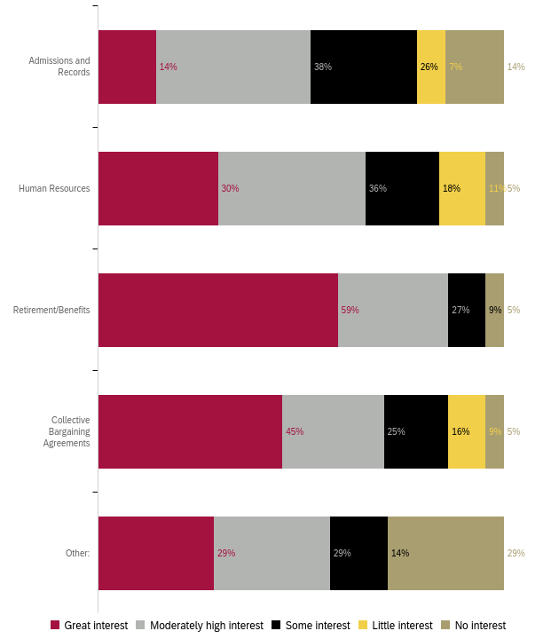
Professional Development for Health and Wellness 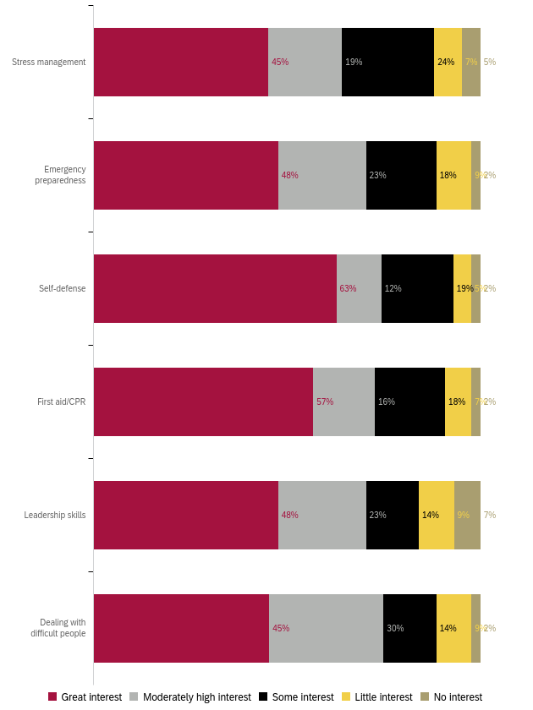
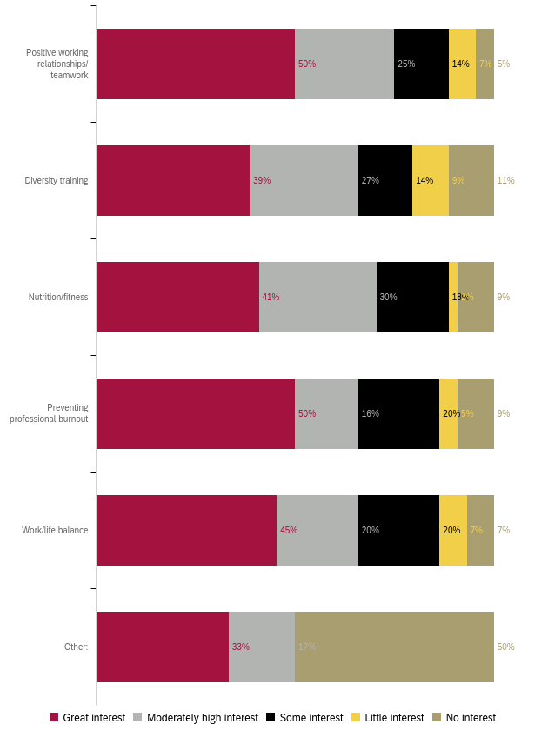
Professional Development to Enhance your Work
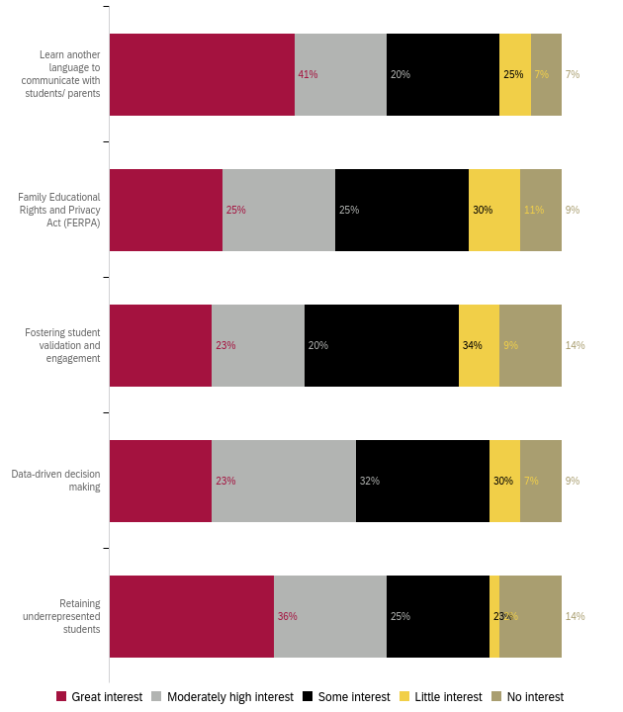

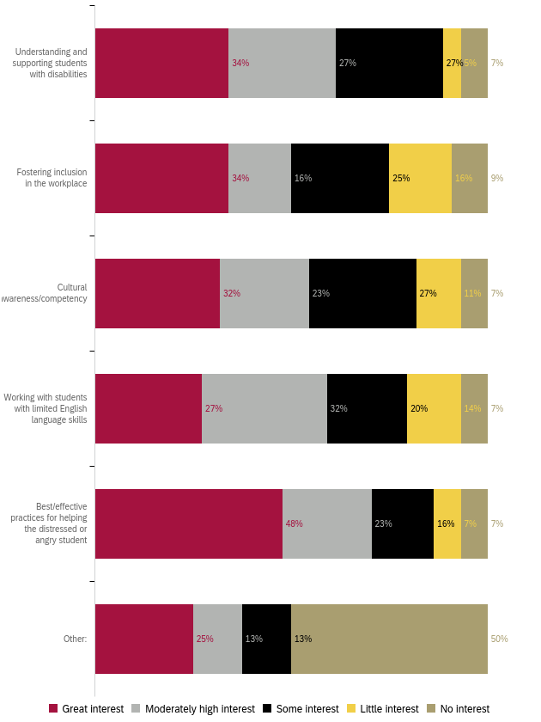
Professional Development for Leadership Skills
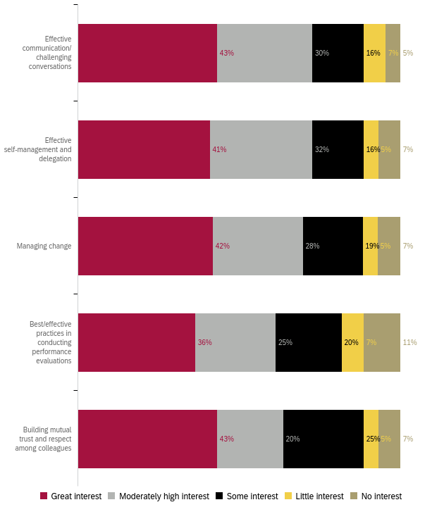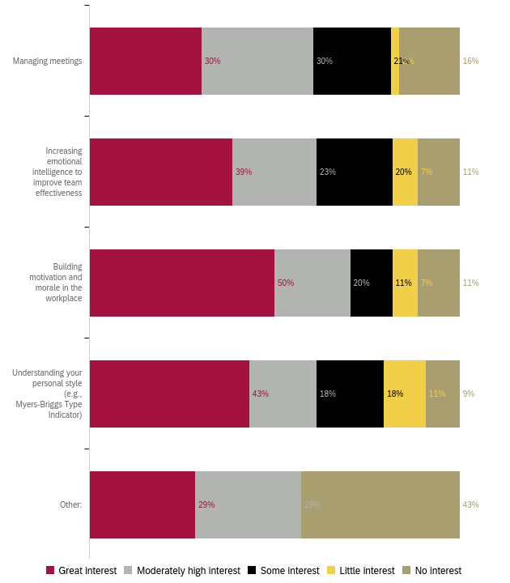

Preferred Professional Development Format 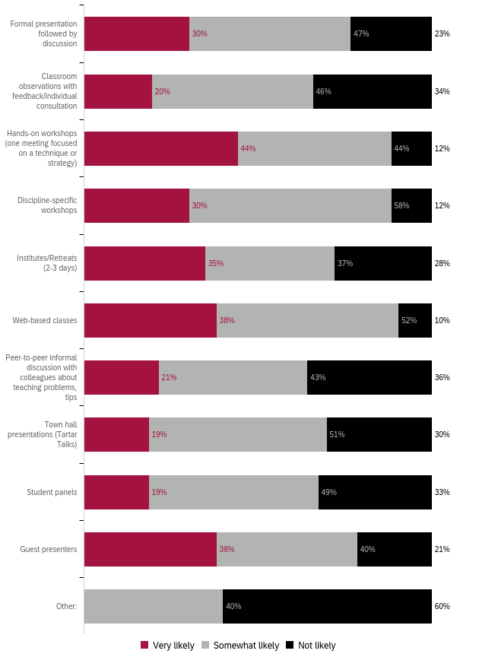

Preferred Format: Ranked 1 (first) to 5 (last)
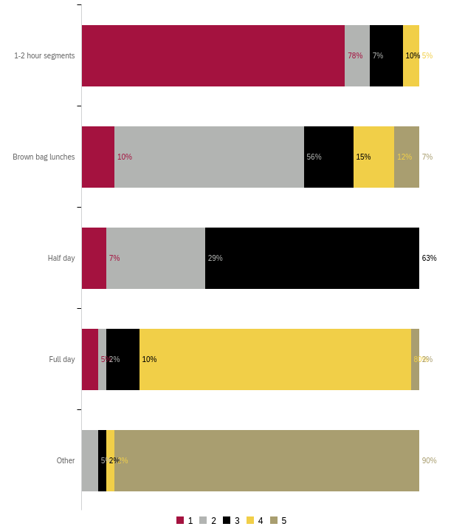
Preferred Day for Training
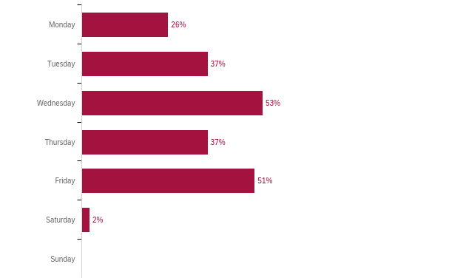

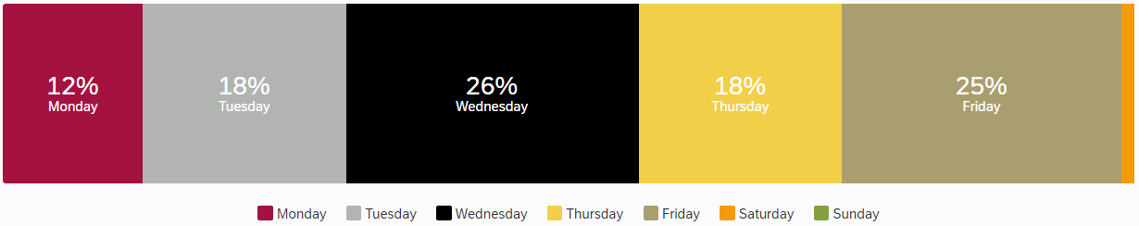

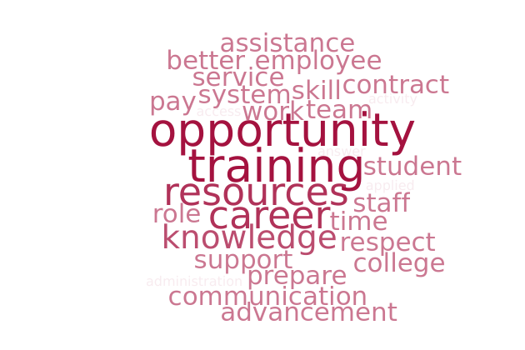
What do you need to enhance your career?

Summary:
The overwhelming majority of the comments (30) were regarding
- Information regarding career opportunities, including advanced degrees
- Software and technology training including Banner, OMNI, and Outlook
- Respect, appreciation, and trust from leadership
Responses:
- A larger team, technological resources (e.g., best laptop possible), a good local database system, career training, more remote work days.
- Understanding and knowledge of promotional opportunities and practices.
- Complete training of Banner and a better system to pull MIS reports.
- Appreciation. A lot of us work hard and cover multiple positions and yet are not really compensated fairly. Bargaining contract is past due and that reflects poorly on Administration, but why should administration care - they get paid livable wages. I don't appreciate that it is so difficult to even get a COLA in our pay. Our benefits package is the pitts. But somehow everyone thinks Professional Development is the answer to everything!
- trust, respect and grace from leadership
- Better tyechnology
- More communication with coworkers and supervisors.
- Opportunities to shadow in other realms of student services aside from my main role.
- access to financial assistance and courses
- Hearing from others career growth and counseling to know what next step are should be. How to prepare to take the next step in our career.
- I would like to gain more knowledge in the area of faculty contracts.
- Decent pay and respect of people when requests are made.
- Proper training on tools and resources to support my role so that I can effectively support students. Open communication and support about getting those tools.
- Having the college to provide programs to prepare employees that have been here for a while to jum start their career to a higher level.
- To be provided release time to attend classes like other employees who were given the opportunity to attend classes.
- opportunity
- Advancement opportunities. Training in college policies and procedures, so they can be applied when needed without delaying the process.
- Advancement Opportunities
- Recognition of the skills I possesss
- Staff support. Resources.
- "Customer services
- Team building activities among staff"
- More knowledge of the always changing technology.
- more training on the Campus OMNI website
- Info on what a career path looks like. Resources to carry it out. Specifically, info on pursuing a graduate / terminal degree.
- Safe Zone training to further education around diversity in genders, sexualities, and family structures.
- Tuition assistance.
- Stress and time management skills.
- Networking events
- N/A (2)
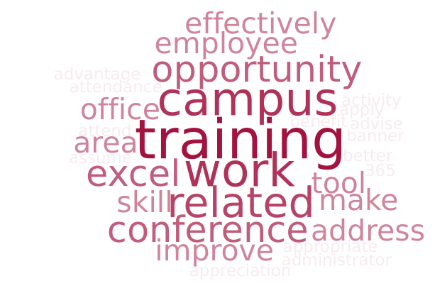
What support or learning opportunity would help you do your job better?

Summary:
An analysis of the 24 responses reveals that most respondents want:
- Training on the processes and timelines of vital offices (HR, Business office)
- Sessions regarding commonly used software: Banner, Microsoft 365, Argos, BEST, CRM Advise, Vision Resource Center, and Outlook
- Information on attending conferences and furthering education
Responses:
- Attending conferences related to my work.
- Complete training for Microsoft Office and 365.
- Better pay and benefits packages, appropriate COLA, appreciation. More remote work opportunities - maybe as an incentive for those that go above and beyond. Also, an open and safe forum for inter office customer service discussions. Some offices make it very difficult to work with them, yet are vital to our day to day activities. The culture on this campus is terrible and should be addressed, and not through lame PD activities.
- conferences that help us learn what other campuses are doing and how we can improve
- More flexibility to take classes.
- major related courses
- Excel training and communication skills.
- I take advantage of online trainings/ and professional development directly related to my area of work.,
- Something that actually applies to my area. However, my area is so specific, it will never be seen as a priority to be catered toward
- Trainings on using CRM Advise/Banner/Website. Having someone to check in, to optimize my work on these tools and periodically address questions or improve use of those tools.
- "Depends on the learning opportunity that will determine what is needed."
- Make training available without assuming, employees already know what processes to follow when they have been internally changed/modify without notification to anyone on campus who are not part of that particular department.
- Leadership skill building and interviewing for manager/director/administrator jobs
- Staff support. Conference attendance regarding specified work-related issues/topics.
- Technology training opportunities. IT
- Many employees lack training in how to effectively use the technological tools available to them. For example, how to write formulas in Excel, how to set up calendar reminders in Outlook, or how to use the Vision Resource Center to earn Flex Credit.
- Excel training. Understanding campus policies and procedures, points of contact, flow of decision-making, etc.
- A retreat away from campus.
- Knowing when to say no in the workplace.
- How to network effectively
- N/A (3)
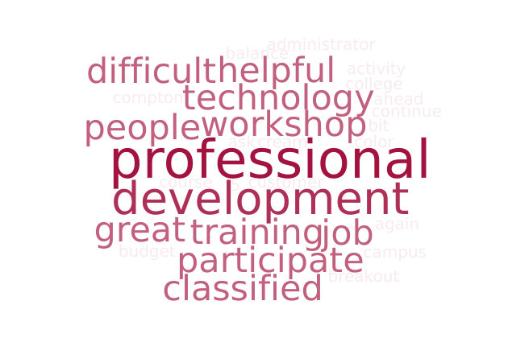
Is there anything else we should know to help build a robust, useful professional development offering?

Summary:
The 19 responses to this question varied widely. One theme that emerged was that of more interactive workshops rather than lectures.
Responses:
- Provide useful presentations not like the ones we have had in the past 5 years or so. We already are inclusive and diverse. We do not need any training on this. These presentations/trainings are a bit a slap in the face because we are already, again, inclusive and diverse.
- make leadership realize that we need to prioritze professional development for classified preofessionals
- offer opportunities by paying for industry specific courses
- Making it more interactive and for there to be more participation from folks participating.
- I think more trainings on technology usage would be helpful, related to security measures and troubleshooting.
- It's difficult to take workshops on work-life balance or improving morale when administrators won't participate or allow for those practices to take place. For example, the expectation that people will work extra in an environment where they feel sorely underappreciated and is so unclean.
- I think it is helpful to have a set schedule a semester ahead for others that may plan ahead. I think professional development sessions involving technology should be publicized similarly to the one's publicized by HR. I have missed out on some technology workshops because they were not sent to all employees.
- Topics should be interesting for everyone involved.
- More fun/informal activities throughout the year that could help with stress during stressful/difficult times. For example, the Ice Cream Social is a fun activity and out of the ordinary that invites us to go out and mingle while we wait to be served.
- A budget for classified professionals
- Compton College does a great job providing a variety of professional development.
- Need to start offering more in-person only events. Joining via Zoom has led to many unfocused, disengaged learners. I've been in serveral meetings on Zoom where logged in individuals were not actually present when asked to respond to a question or join a breakout room.
- "Continued focus on diversity in speakers: fewer white men, more women of color, people with disabilities, queer/trans folx, immigrants, etc. Pilar, you do a great job!"
- Campus wide Customer Service.
- N/A (5)
Appendix A: “Other” Responses
What is your ethnicity “Other” responses:
- Hispanic (2)
- Mexican-American (2)
- Hispanic/Latin
- Latino/a

What is your area “Other” responses:
- BUSINESS AND INDUSTRIAL STUDIES
- HR
- Financial aid
- Child Development Center (2)
- Assisrant
- N/A
- Anonymous

Non-participation “Other” responses:
- Workload deadlines, therefore, request will be denied.
- I did participate in PD
- Scheduled events are usually happening outside of my work schedule or at a time when I cannot be away from my area
- It depends on the activities.
- N/a
- Proctoring a computer assessment
- I always participate unless there is a schedule conflict

PD for GPD “Other” Responses
- students to have a working computer
- Conflict managament and resolution in the workplace, Management styles: disadvantages, advantages,examples

PD for Technology “Specific Applications” responses:
- Excel (3)
- Adobe
- Schedule zoom meetings, and appointments
- Apple Training
- Use of CRM Advise to communicate with students
- BEST
- Zoom

PD for Technology “Other” responses:
- Apple Training
- Faculty Contract/ Course
- How to use VRC Professional Development / Flex features
- calpers website nav

PD for Policies and Procedures “Other” responses:
- Active Shooter / Earthquake preparedness

PD for Wellness “Other” Responses
- AED / Fire Extinguisher use

PD for Work “Other” Responses
- Personal Career Planning - What's the next step up?

PD for Leadership Skills “Other” responses:
- Progressive discipline

PD Format (types of trainings) “Other” responses:
- CANVAS Trainings
- Virtual / Online
- Self-paced
- Multiple Half Days

“Other” responses listed in Appendix A
“Other” responses listed in Appendix A
“Other” responses listed in Appendix A
“Other” responses listed in Appendix A
“Specific Applications” and “Other” responses listed in Appendix A
“Other” responses listed in Appendix A
“Other” responses listed in Appendix A
“Other” responses listed in Appendix A
“Other” responses listed in Appendix A
“Other” responses listed in Appendix A
“Other” responses listed in Appendix A

