Professional Development Needs Assessment
Spring 2023 – Faculty
Business and Industrial Studies
Respondent Demographics

What is your ethnicity? What is your gender?
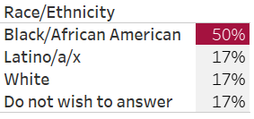
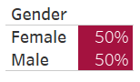

What is your area? How long have you worked at Compton College?

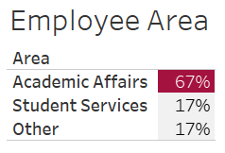
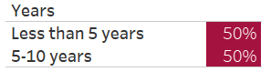

What kept you from participating in professional development activities?

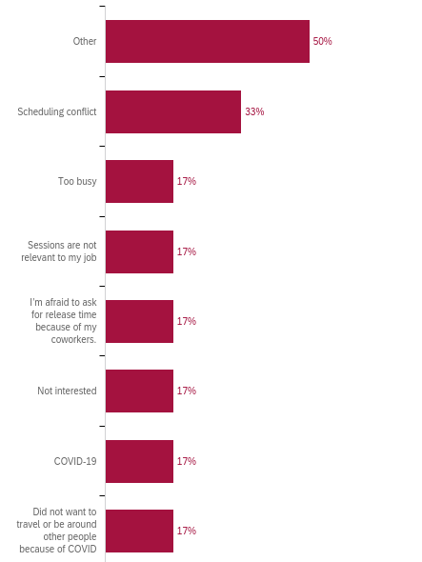

How many professional development hours did you attend in the last year?
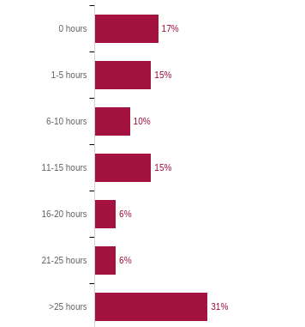

Professional Development for Guided Pathways
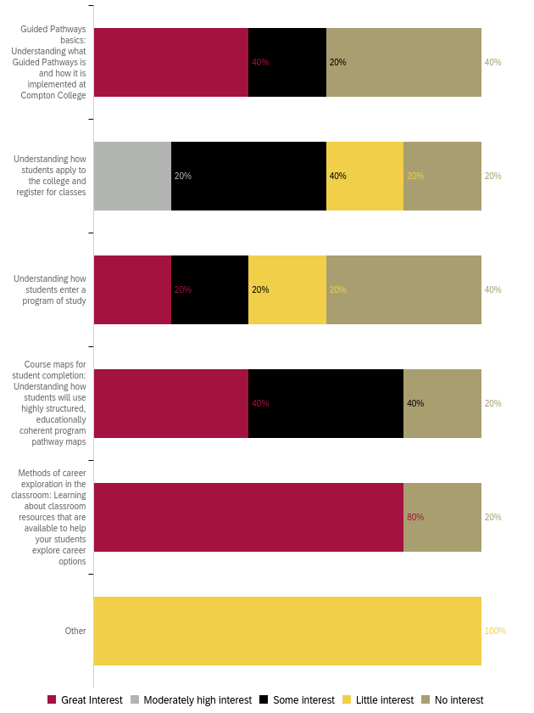
Professional Development to Enhance Teaching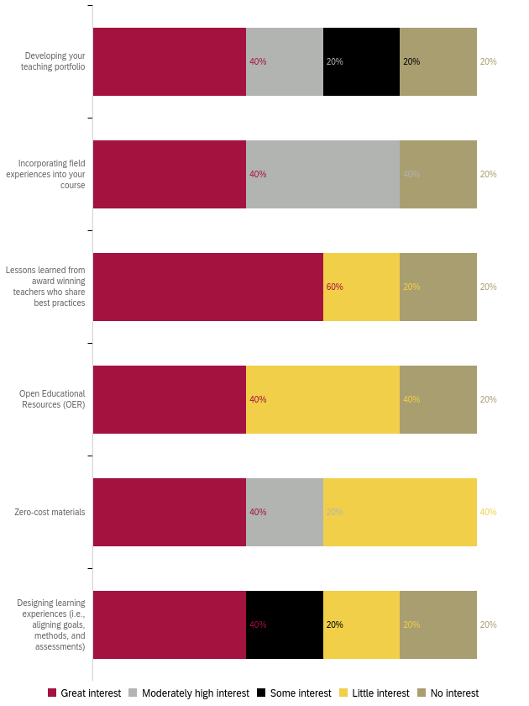
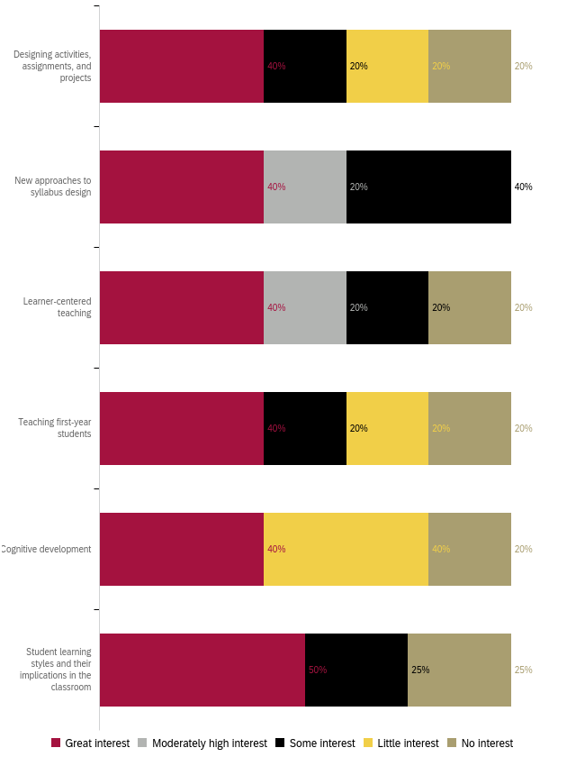
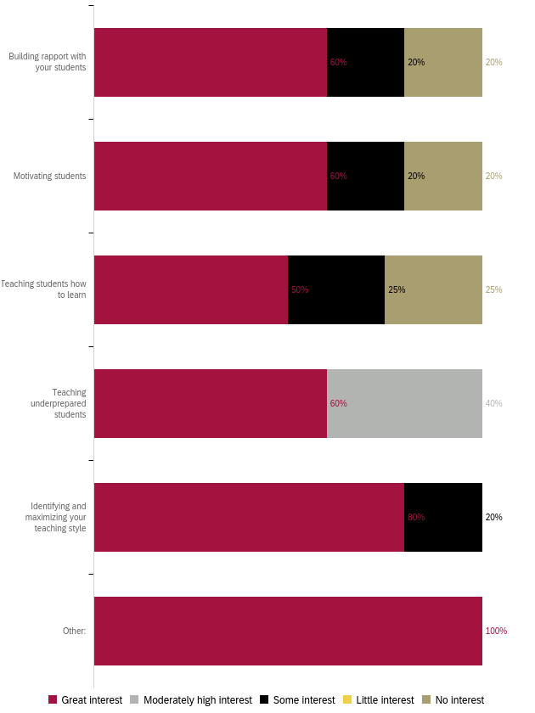
Professional Development for Curriculum Development 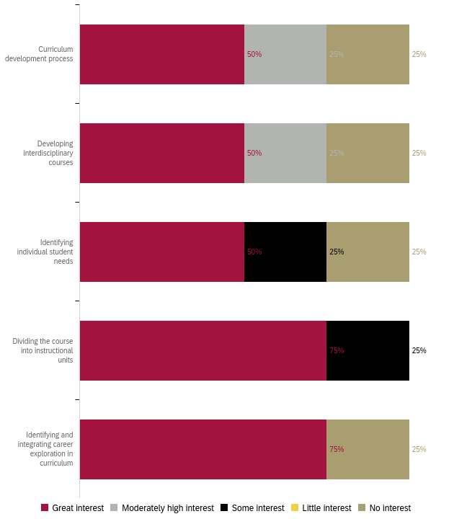

Professional Development for Diversity, Equity, and Inclusion in the Classroom
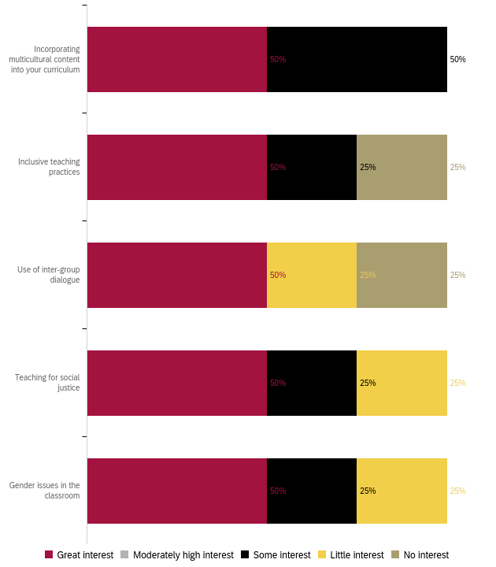

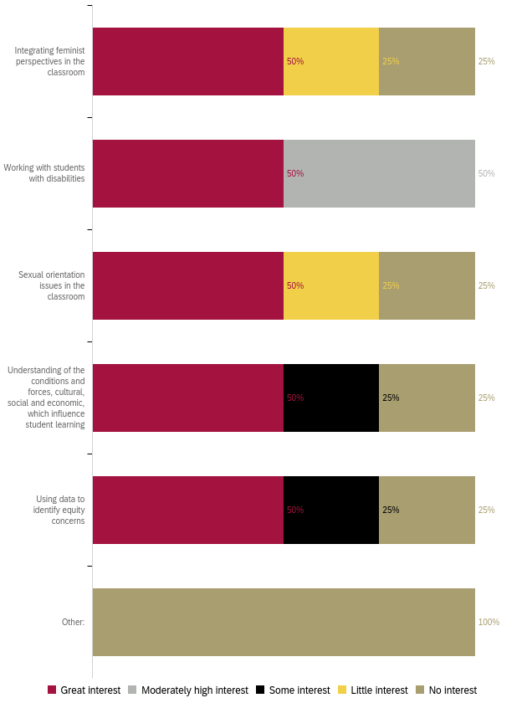

Professional Development to Improve Assessment
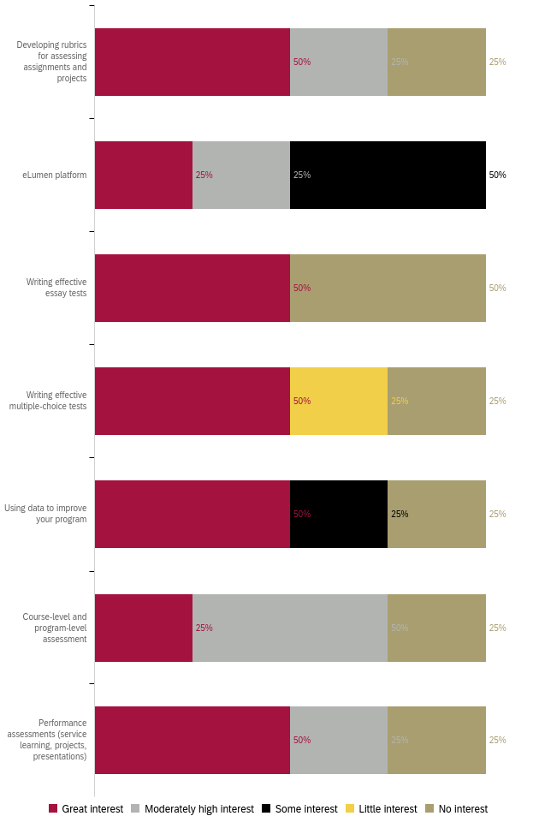

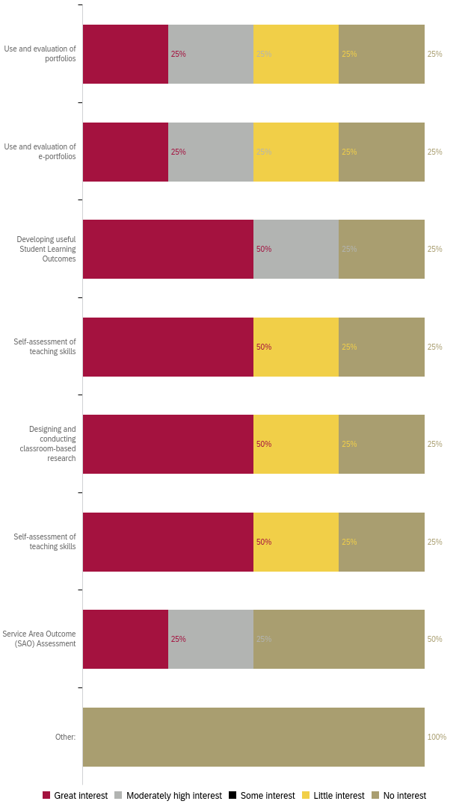

Professional Development for Use of Technology
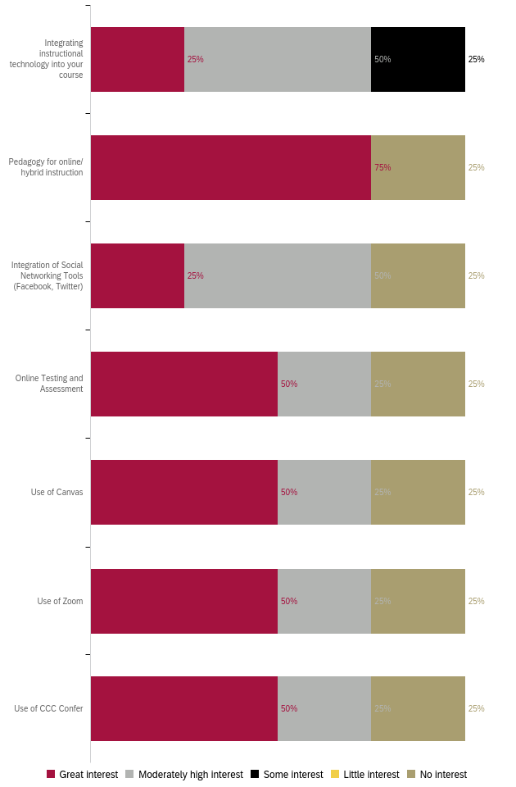
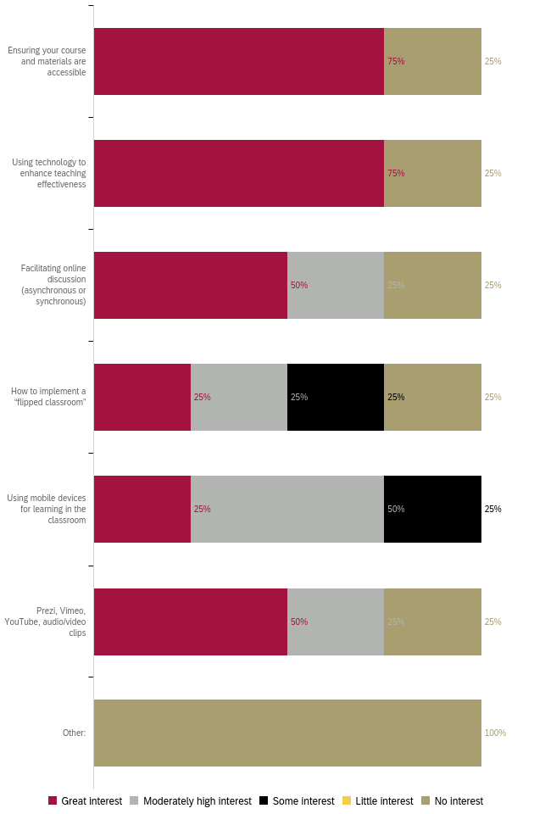
Professional Development for General Use of Technology
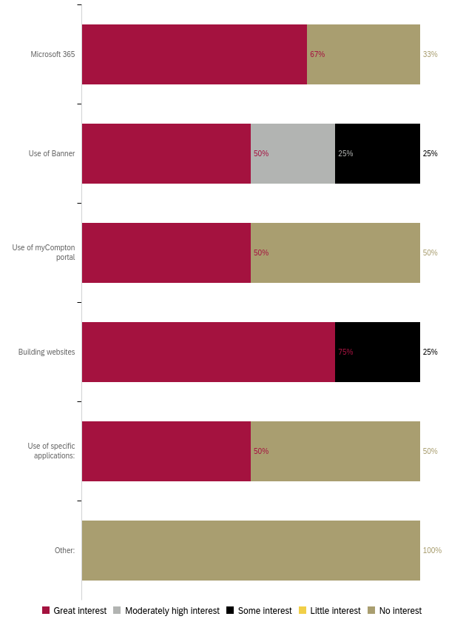

Professional Development for Classroom Management
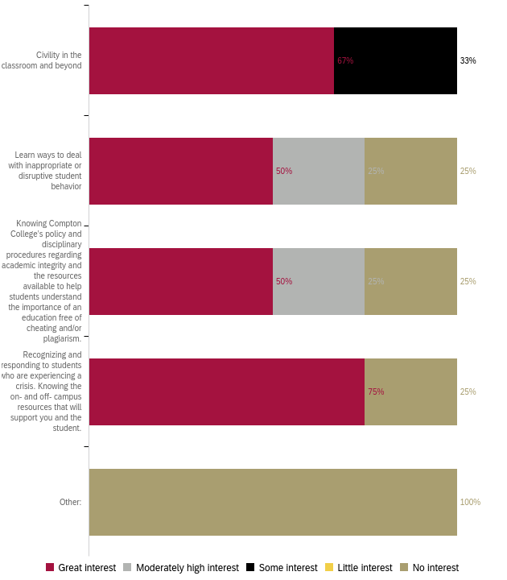

Professional Development for Compton College Policies and Procedures
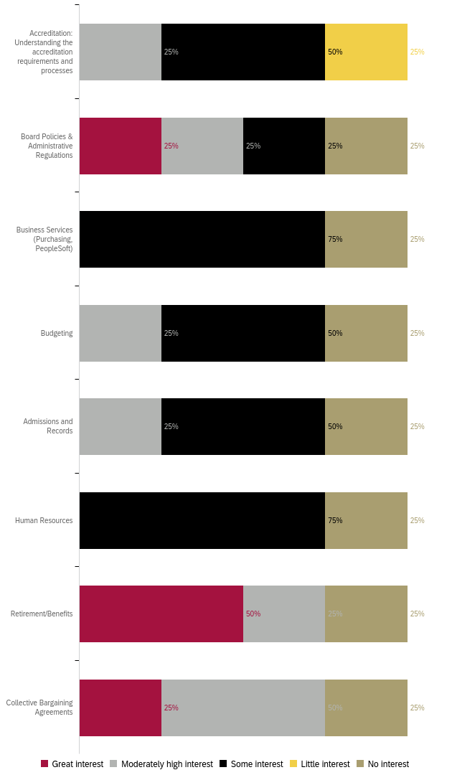
Professional Development for Health and Wellness 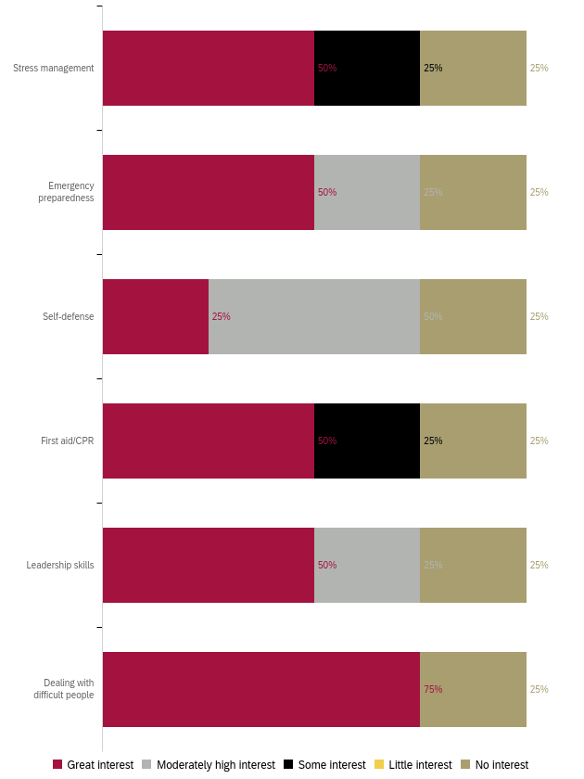

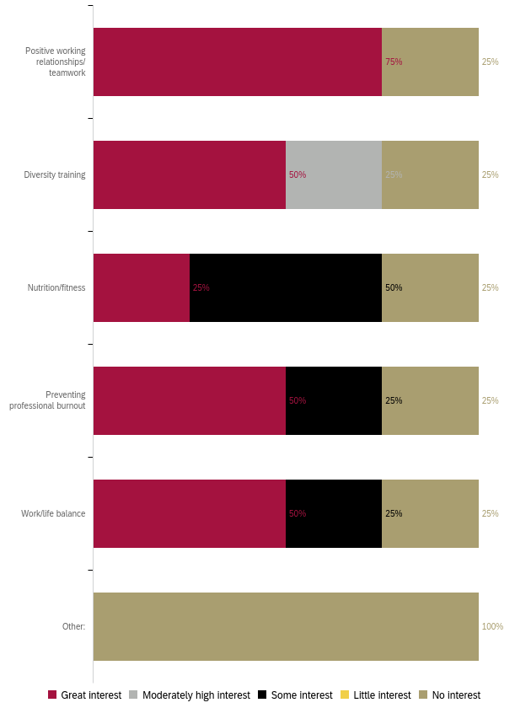
Professional Development to Enhance your Work
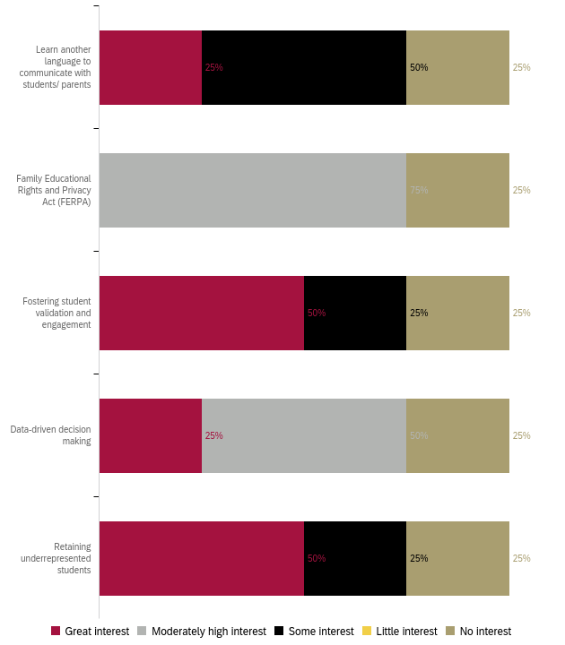

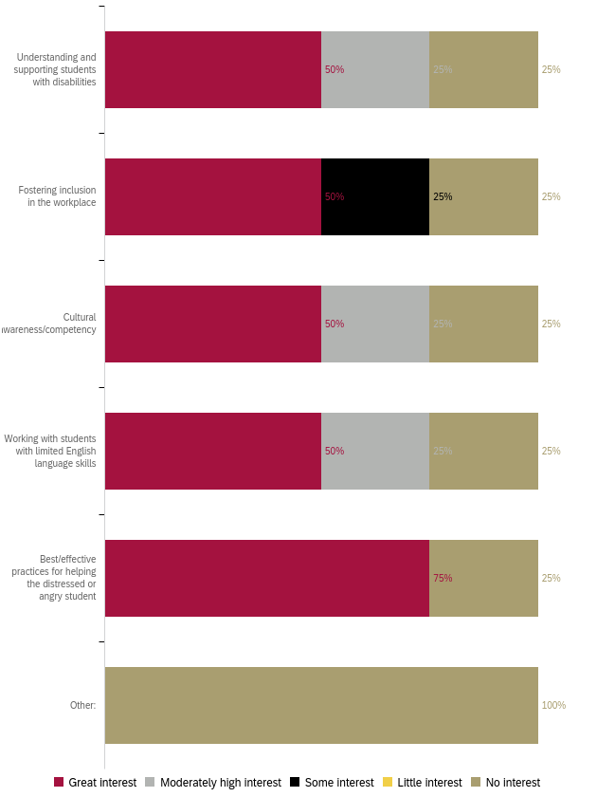
Professional Development for Leadership Skills
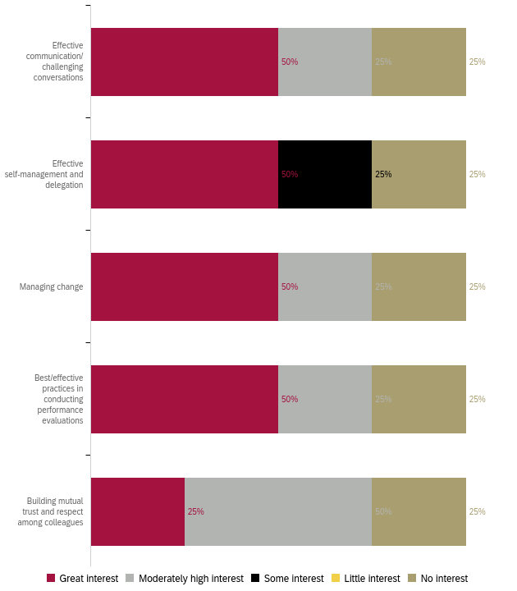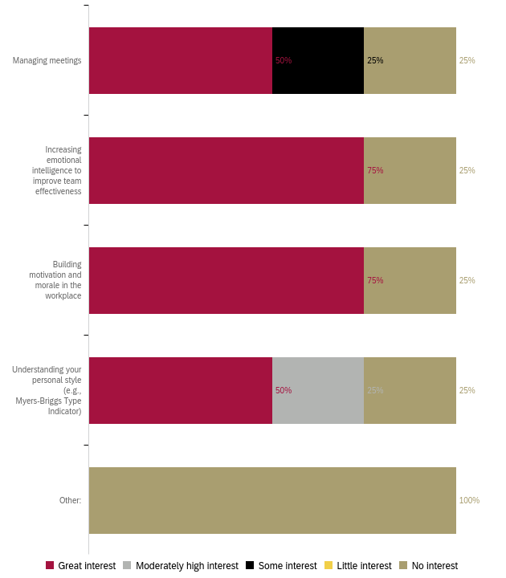

Preferred Professional Development Format 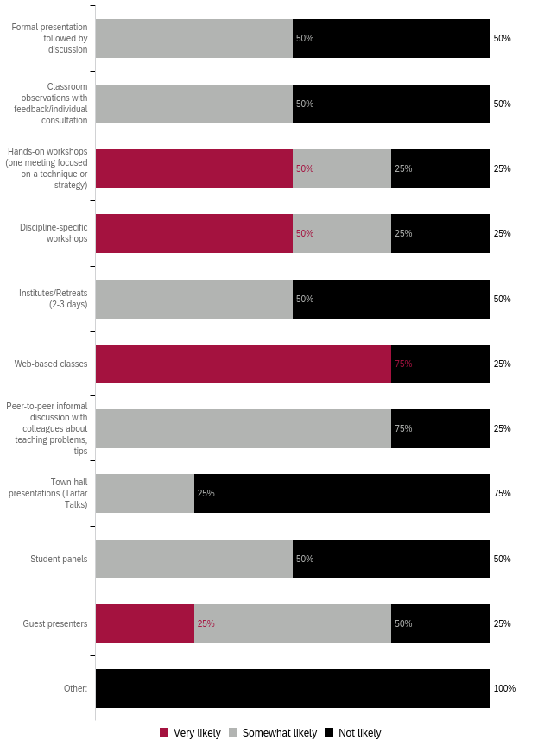

Preferred Format: Ranked 1 (first) to 5 (last)
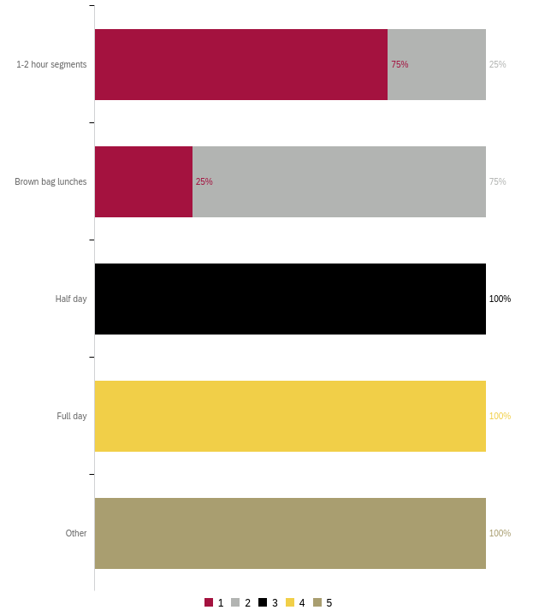
Preferred Day for Training
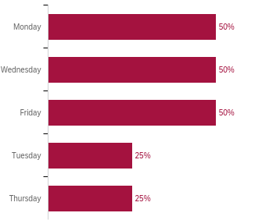

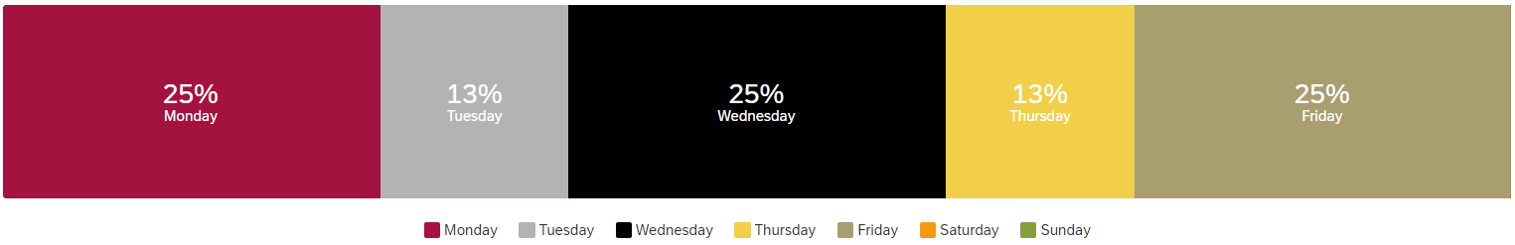

What do you need to enhance your career?
Responses:
- Trainings in technology, communication, conflict resolution, supporting marginalized students
- To learn the specific needs of this institution in order to help fill the gap and solve the needs of this institution.
- More Canvas aNnd other online training
What support or learning opportunity would help you do your job better?
Responses:
- N/A
- Hands on workshops
- Having someone readily available through email communication so that whenever I have a question I can email them and get a prompt response.
Is there anything else we should know to help build a robust, useful professional development offering?
Responses:
- N/A

Appendix A: “Other” Responses
Non-participation “Other” responses:
- wasn't working at compton
- I wasn't employed at Compton College yet
- I did not know i could request a sub to attend PD events.

PD for Teaching “Other” responses:
- Ethics

“Other” responses listed in Appendix A
“Other” responses listed in Appendix A
“Specific Applications” responses listed in Appendix A
“Other” responses listed in Appendix A

