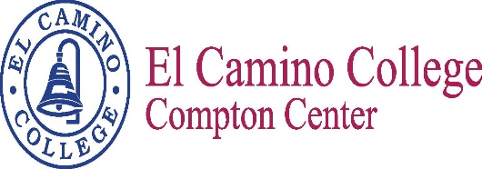

Name of meeting
Minutes
Meeting Date
Meeting Time

Vision
El Camino College Compton Center and the future Compton College will be the leading institution of student learning and success in higher education.

Mission Statement
El Camino College Compton Center and the future Compton College is a welcoming environment where the diversity of our students is supported to pursue and attain academic and professional excellence. Compton Center promotes solutions to challenges, utilizes the latest techniques for preparing the workforce and provides clear pathways for transfer, completion and lifelong learning.

Meeting Participants

Jose Villalobos | Estina Pratt | Carmela Aguilar
Shateo Griffin | Nelly Alvarado | Abiodun Osanyinpeju
Richette Bell | Elizabeth Martinez | Jessica Sanchez
Arnette Edwards | Bailey Smith

Meeting Minutes

Jose Villalobos called the meeting to order.
- Bailey, Nelly and Shateo gave a recap of the Student Success Summit
  - Summit held May 19th; 43 people in attendance
  - Great diversity of roles in management and faculty
  - There were no students this time, however will plan to have students at the next summit
  - Went over different formulas for each initiative; had interactive activities to see where each person role fit in with each activity
  - Pulled together ideas that were common among all the groups
    - Professional Development was the main topic across the board with both front line staff and faculty. PD is not necessarily a goal for integration, however there is a section on the integrated plan where we can include PD opportunities on campus in general.
  - Summary of feedback was positive. Some of the items most mentioned were the different formulas used for funding. Most people weren’t aware of the different formulas used for funding. Integration, collaboration and communication were also mentioned as being vitally important. Data and research is something that most people would like to see. And most people want to know about how it is all going to play out once it hits the ground.
- Nelly and Bailey provided information on the five integrated goals and how they were decided
  - On the handout provided (rough draft of integrated goals) is an example given by the Chancellor’s office on how to integrate a goal. So you’ll see the Goals that we have come up with. They will need to be worked on to define them a little better. This is just a rough draft. We have already started to edit it
  - We are most likely going to collapse #2 and #3
  - The minimum goals you can have are 5. You can add additional ones if you want, but it is not really recommended. Whatever you have you will be required to complete
  - Again, this is being edited and re-worded so it is still a work in progress
  - Data is still being gathered
  - Planning to have a working draft by August 5th; it will be approved and implemented in January 2018
  - Goals will be sent in electronic format by Bailey so that you can all provide feedback

The Next Scheduled Meeting
August 3, 2017
1:00 pm/E38

