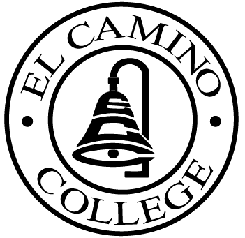
Student Success Committee Meeting | October 27, 2016  1:00 p.m. – 2:00 p.m.  Room E38
AGENDA

SEP Projects Update - Bailey Smith

SSSP Updates - Nelly Alvarado and Shateo Griffin

SSC Plan Review - Albert Jimenez

***************NEXT MEETING IS TUESDAY, NOVEMBER 22, 2016 at 1:00 PM***************

