Professional Development Needs Assessment
Spring 2023

Managers
n=24 | Response rate=65%

What is your Guided Pathways Division? What is your ethnicity?
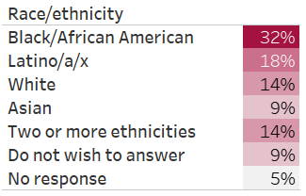
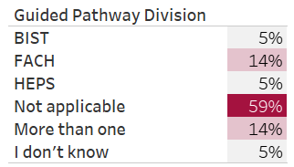

What is your area? What is your gender?
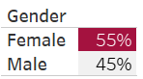
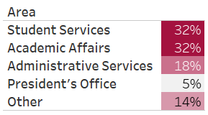

How long have you worked at Compton College?
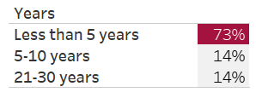

What kept you from participating in professional development activities?

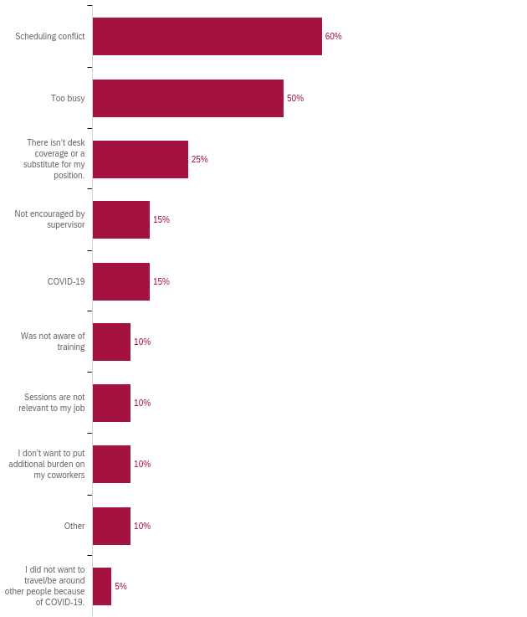

How many professional development hours did you attend in the last year?

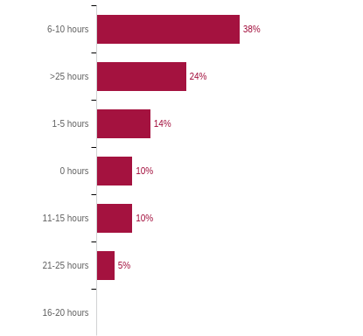

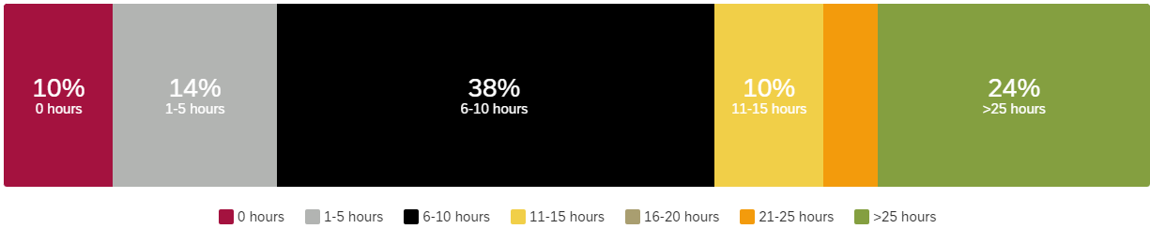

Professional Development for Guided Pathways
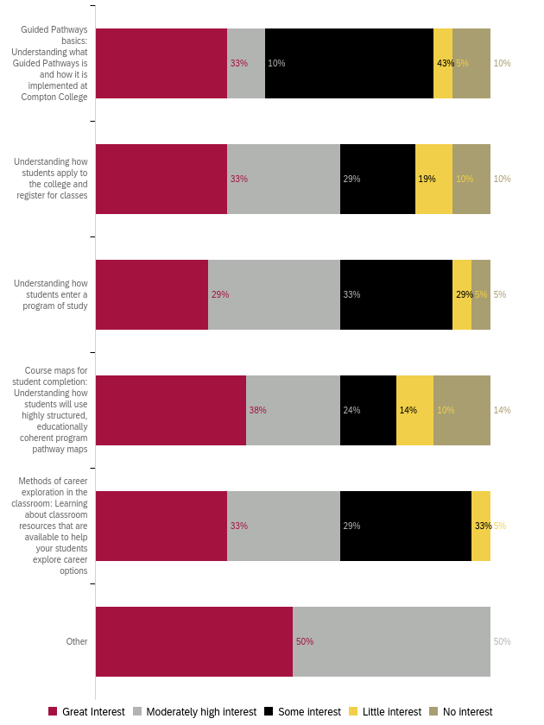
Professional Development for General Use of Technology
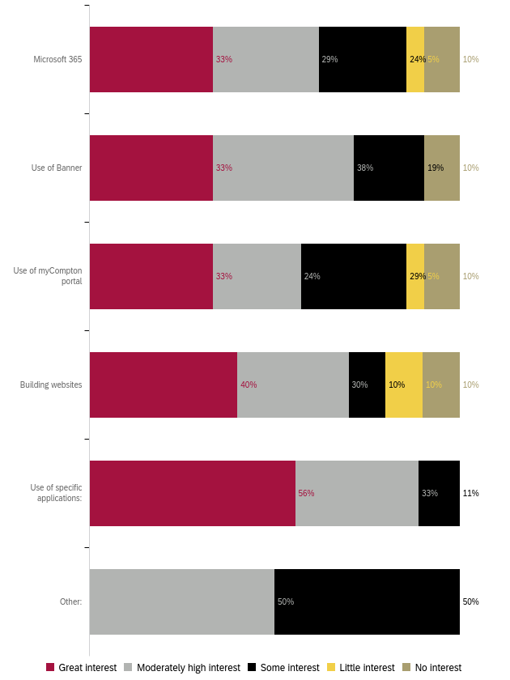

Professional Development for Compton College Policies and Procedures
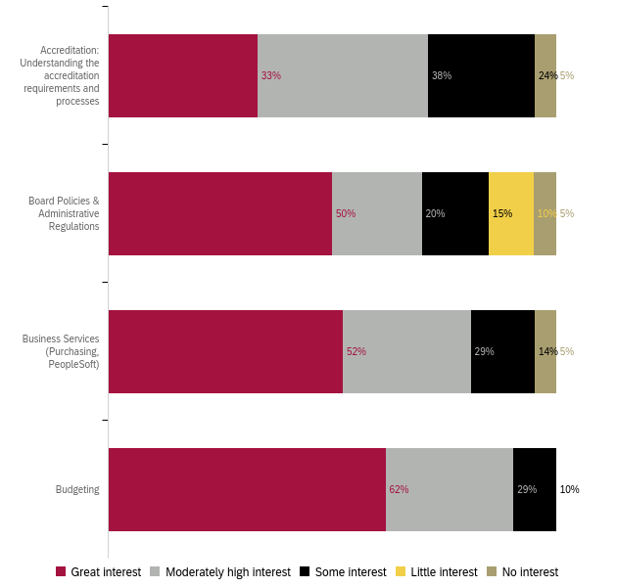
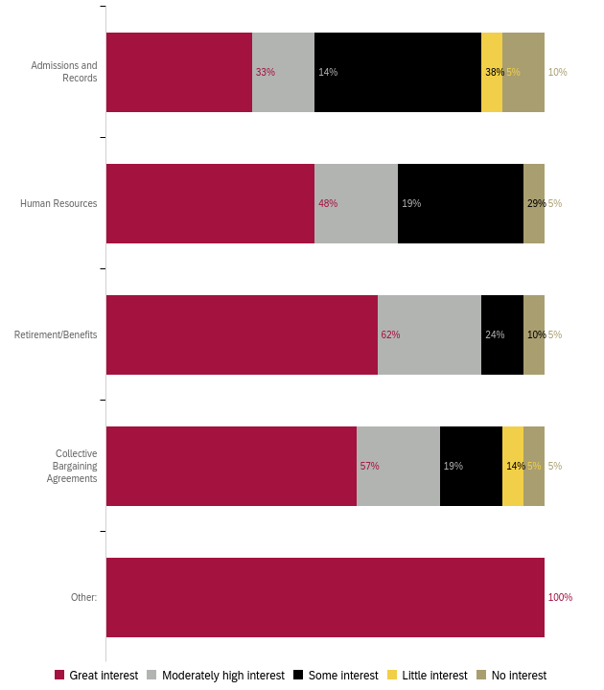
Professional Development for Health and Wellness 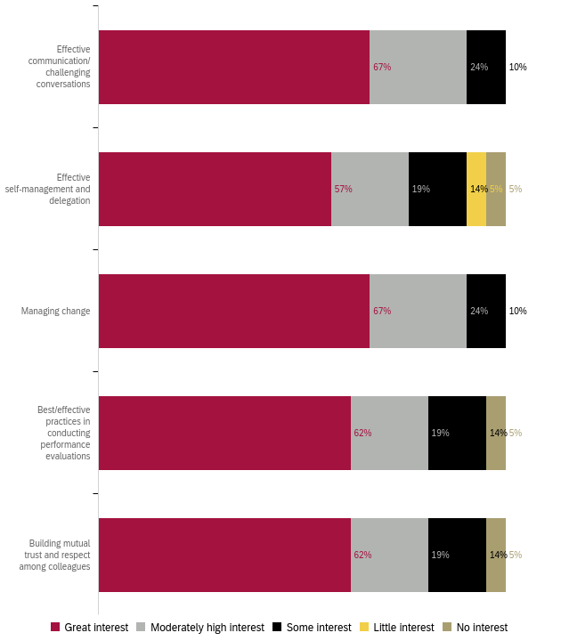

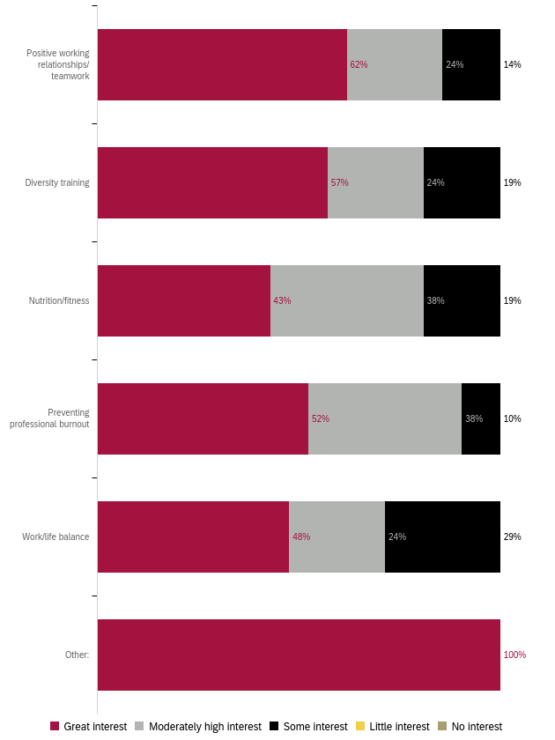
Professional Development to Enhance your Work
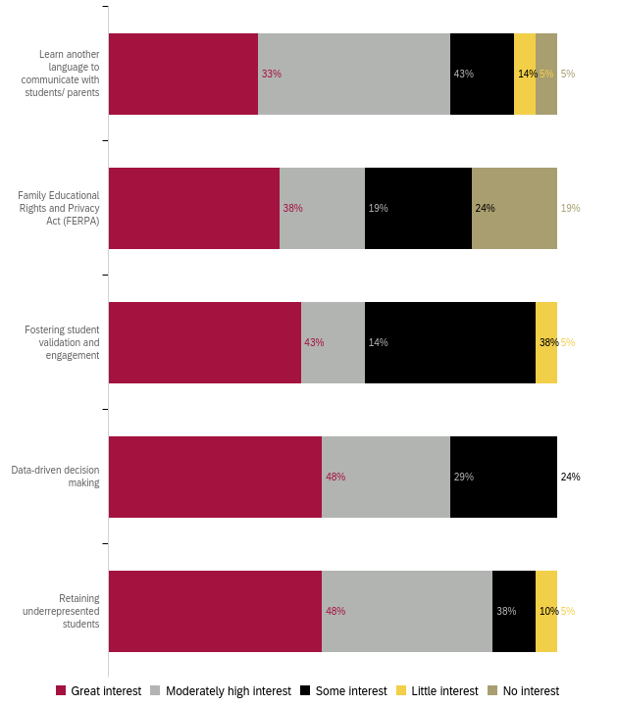

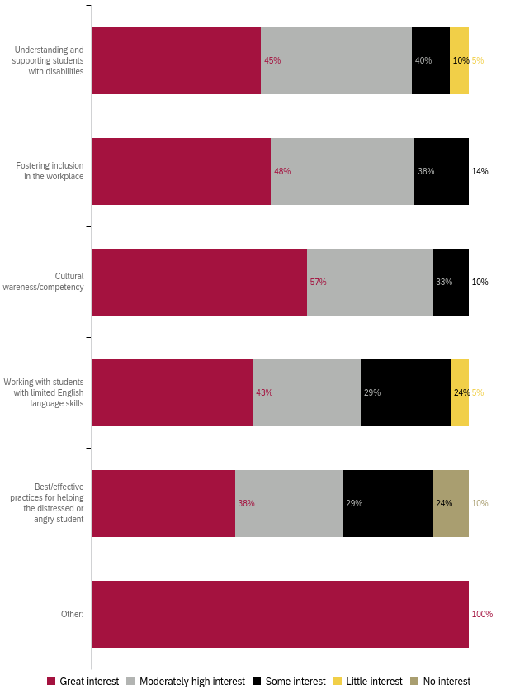
Professional Development for Leadership Skills
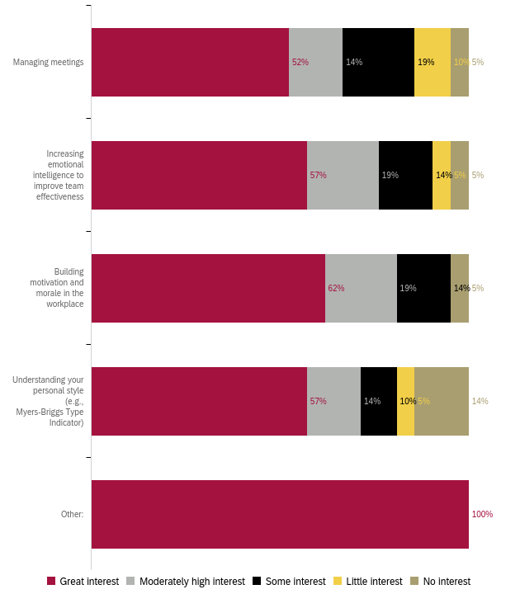

Preferred Professional Development Format 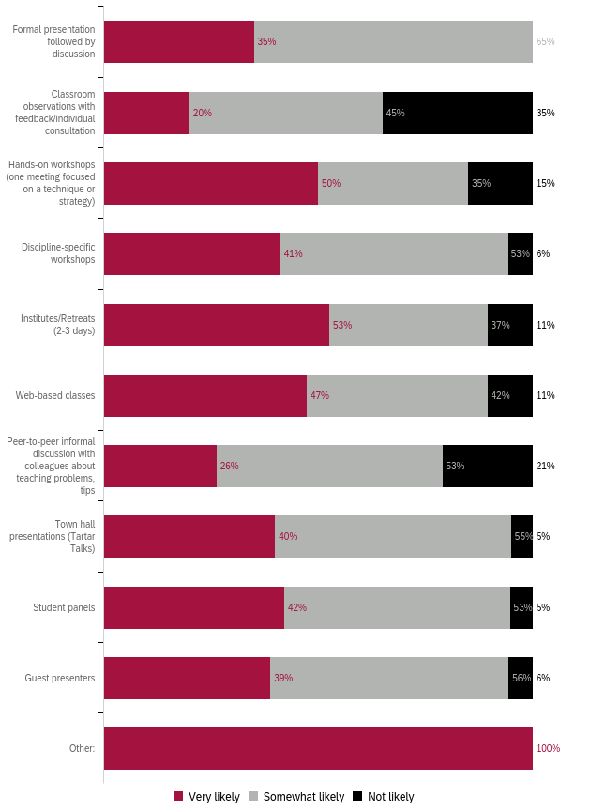

Preferred Format: Ranked 1 (first) to 5 (last)
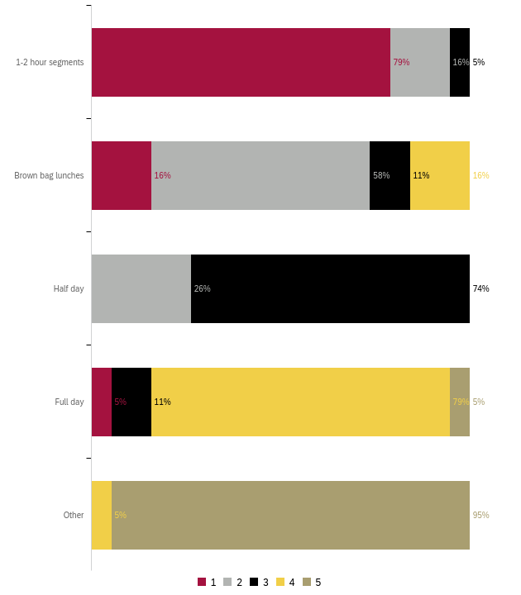
Preferred Day for Training
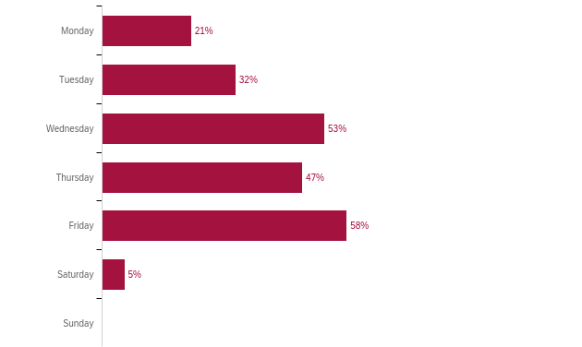

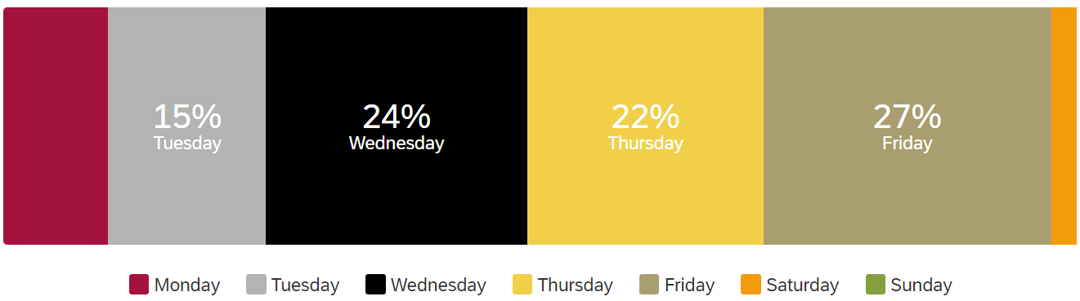

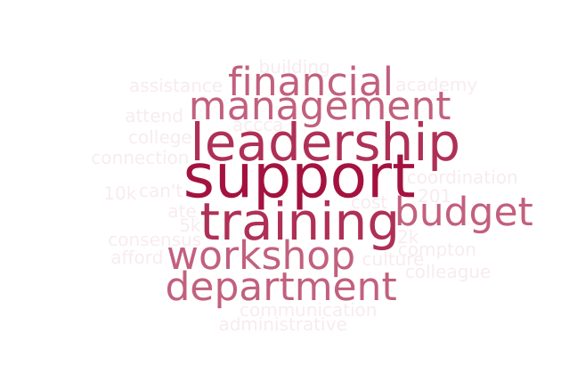
What do you need to enhance your career?

Responses:
- No resources and training
- Upper Management Support
- Financial support.
- Training on optimizing Outlook
- Learn more about department procedures, for example, requisitions, request for a room, etc.
- Leadership led direction to increase inter-departmental communication, connection, and discussion on improvements to internal interactions
- More time!
- Administrative assistance, budgeting workshops, performance evaluation workshops, building consensus, growing work development teams, implementing new strategic planning
- Financial support to attend PD outside of Compton College. For example, ACCCA 201 cost over 2k. I can't afford that. I attended NCCHC and that was over 5k. My VP paid for it and I want to say that ate up her budget. The Liderazgo Leadership Academy with HACU is over 10k. I want to attend these trainings, but they cost money, funds I do not have.
- Support with leadership and management techniques that are practical and coordination with my colleagues to support an inclusive culture.
- workshops
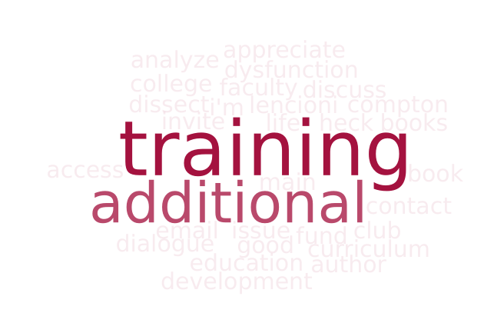
What support or learning opportunity would help you do your job better?

Responses:
- More outside training
- Upper Management Support
- Additional education.
- Training on the curriculum development process translated for non-faculty members.
- Training or email on Compton College systems used and their main point of contact
- More staff, more time, access to additional programs and funding.
- All of the above.
- I think what would be good is to have a manager's book club. I'm not volunteering for it but we should read books like Lencioni's book on the five dysfunctions of a team, etc. Books like this where we can review together, dissect, and analyze. Heck, maybe even invite the authors.
- I would appreciate an open dialogue to discuss real life issues and share resources.
- workshops
Is there anything else we should know to help build a robust, useful professional development offering?

Responses:
- Great job
- N/A (3)
- Professional development can be organized in a way that it does not impact one's duties and responsibilities. It should not be imposed but planned for a period, e.g. The fiscal year so it does not interfere with deadlines.
- Add Group Q&A in place of Breakout Rooms
- Less one-way meetings and greater collaboration among professionals.
- Executive leadership should highlight the PD trainings in our meetings and make them mandatory so we can attend.
- I see a great deal of effort and support by the District in this regard, but it would help to have champions for these efforts strategically across campus to build capacity.
What is your Area “Other” responses
- Human Resources (3)

PD for GPD “Other” responses:
- Technology, Curriculum, Resources

PD for Technology “Specific Applications” responses:
- Reporting Software
- Excel

PD Format (types of trainings) “Other” responses:
- Zoom

“Other” responses listed in Appendix A
“Other” responses listed in Appendix A
“Specific Applications” responses listed in Appendix A
“Other” responses listed in Appendix A

