Professional Development Needs Assessment
Spring 2023
Classified Professionals and Administration
n=80 | Response rate=45%

Analytical Summary
Demographics
Responses of “Identity not listed” and “Do not wish to answer” for some demographic questions have increased by one to two percentage points, indicating that this survey may need to include more descriptive options in the answer selections. Over half of respondents (52%) have been at Compton College for less than five years, 70% have been employees for less than 5 years, and 19% had more than 21 years of tenure.
Barriers to participation
Respondents cite scheduling conflicts as the main barrier to participation at a much higher rate than 2021-22 (57%, 41% respectively), while personnel responding “Too busy” increased dramatically from 25% to 40%. Instances of COVID, are cited more frequently (18% as opposed to 14% in 2021-22), and COVID-related fears of travelling/communing were expressed by 10% of respondents. Awareness of trainings has increased, though, with faculty citing “I was not aware” four percentage points less than last year (9%, 13% respectively). Classified professionals responding that they were “Not encouraged by supervisor” quadrupled from 3% to 12%.
Hours of participation
More respondents were able to spend more hours in professional development trainings, as the percentage of those spending zero hour dropped four percentage points (16% to 12%) while most other categories grew.
PD topics
Interest in PD topics in some areas increased by around 10 percentage points while many others remained the same or even decreased slightly. The primary topics of interest are technology, leadership skills, health and wellness, and policies and procedures. Three major themes are conflict resolution, supporting marginalized students, and understanding the CalPERS retirement system.

Respondent Demographics
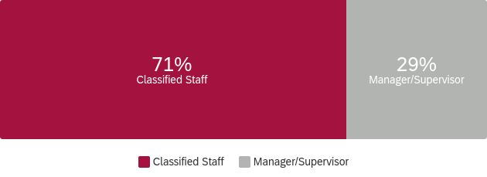
What is your Guided Pathways Division? What is your ethnicity?
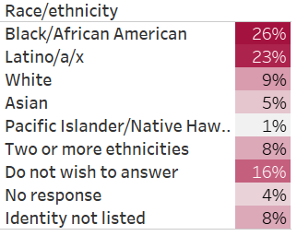
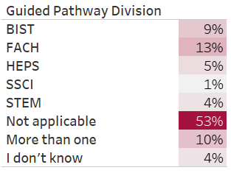

What is your area? What is your gender?
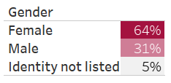
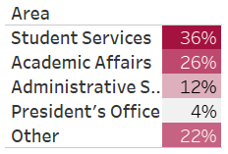

How long have you worked at Compton College?

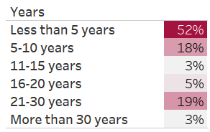

What kept you from participating in professional development activities?
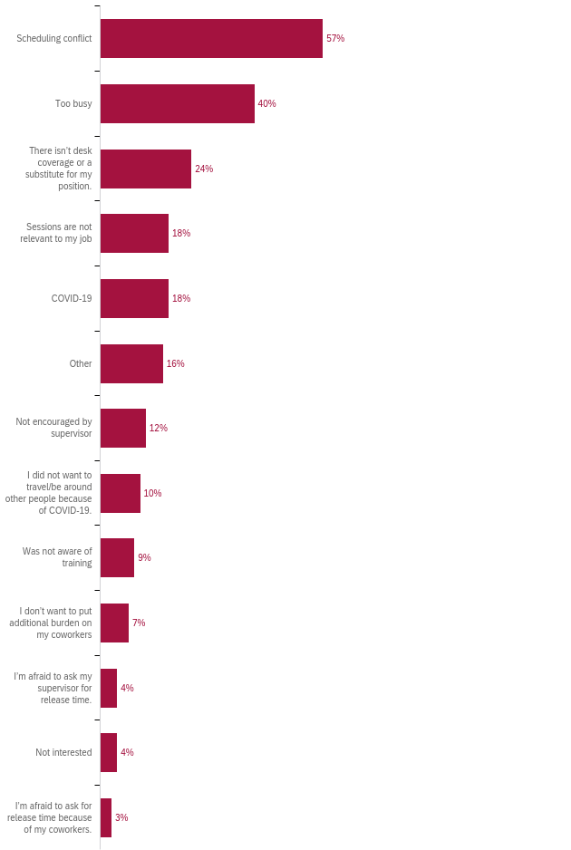

How many professional development hours did you attend in the last year?
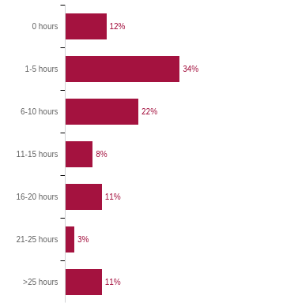

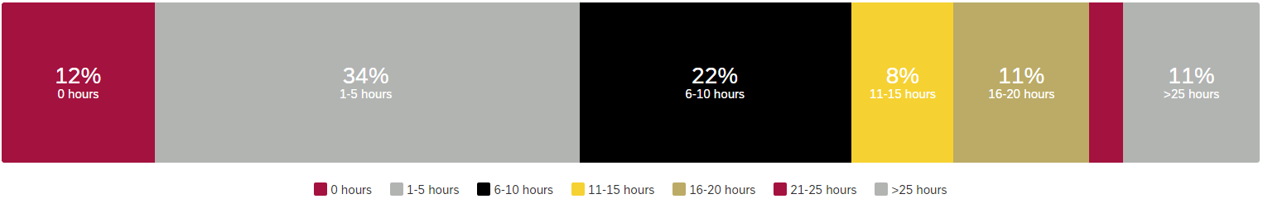

Professional Development for Guided Pathways
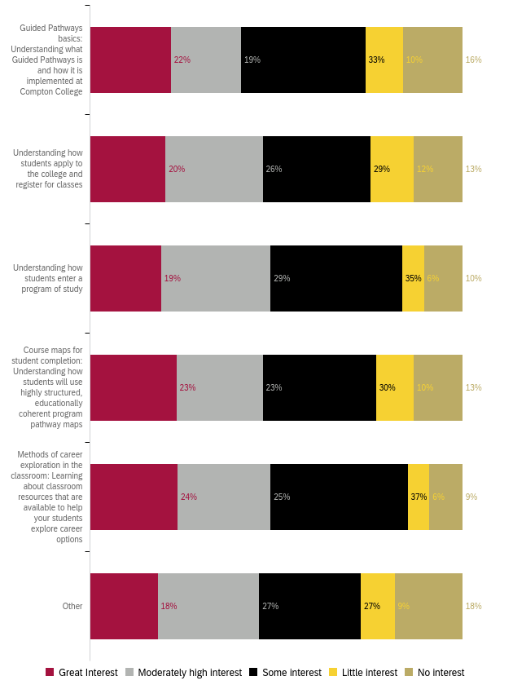
Professional Development for General Use of Technology
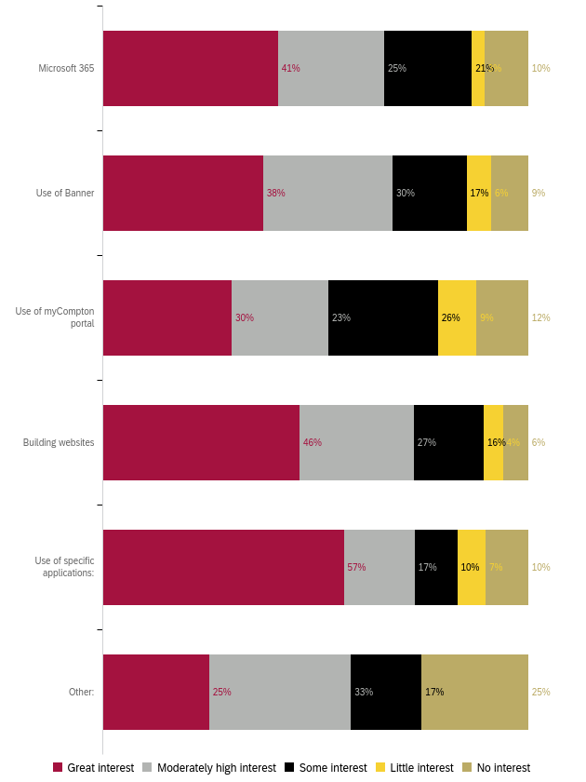

Professional Development for Compton College Policies and Procedures
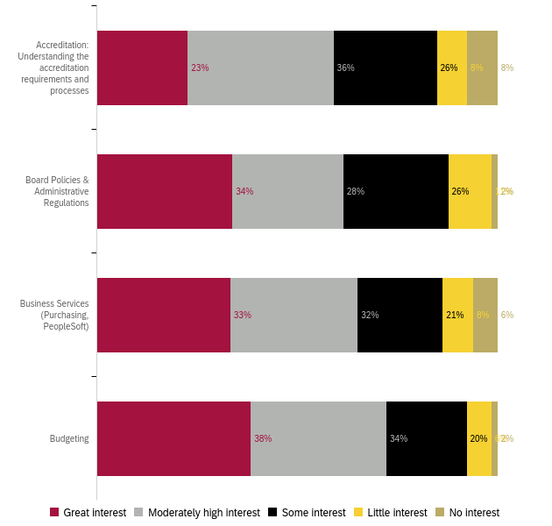
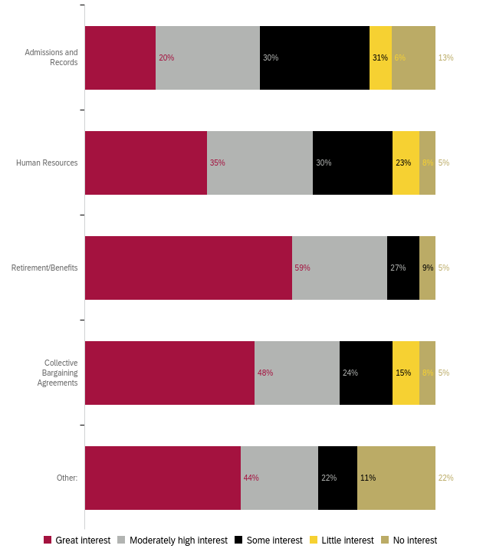
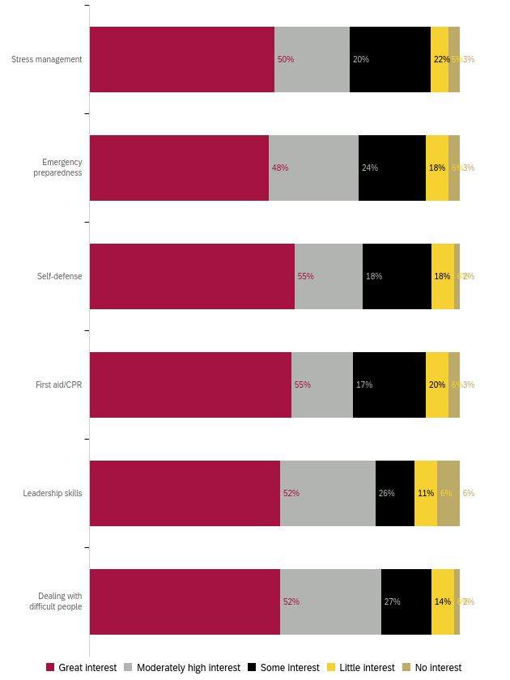
Professional Development for Health and Wellness
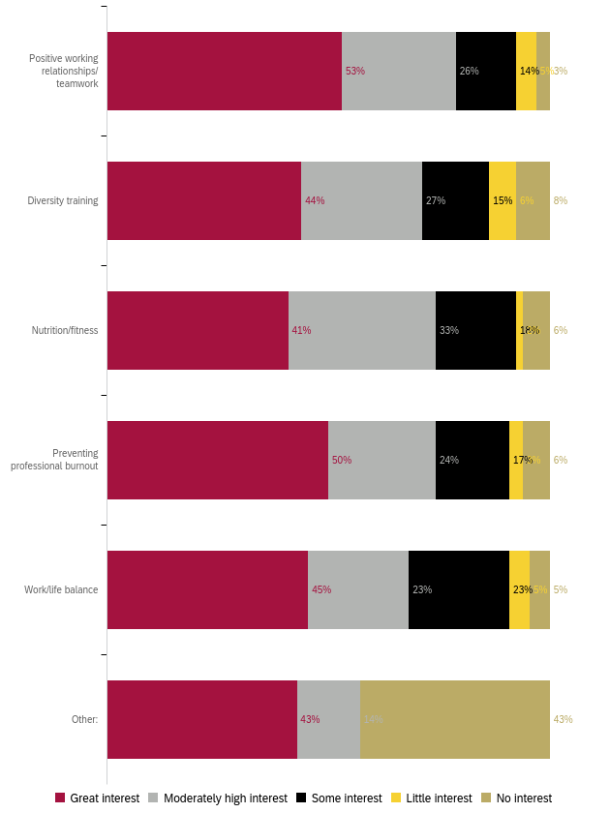
Professional Development to Enhance your Work
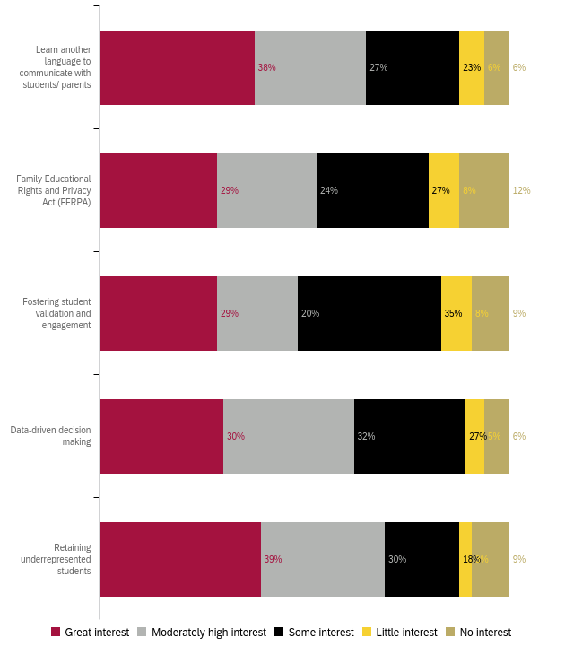

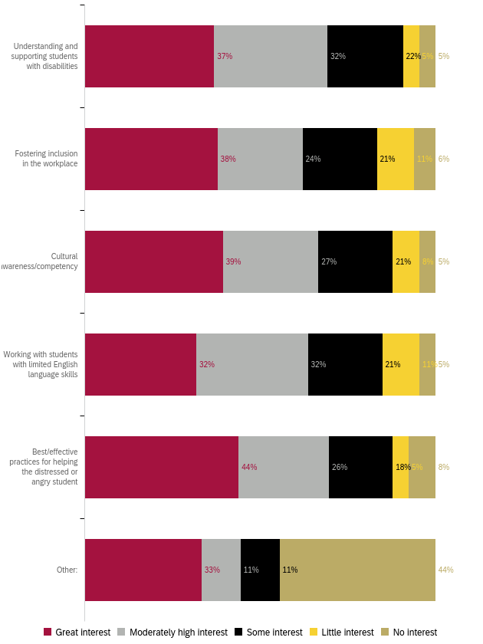
Professional Development for Leadership Skills
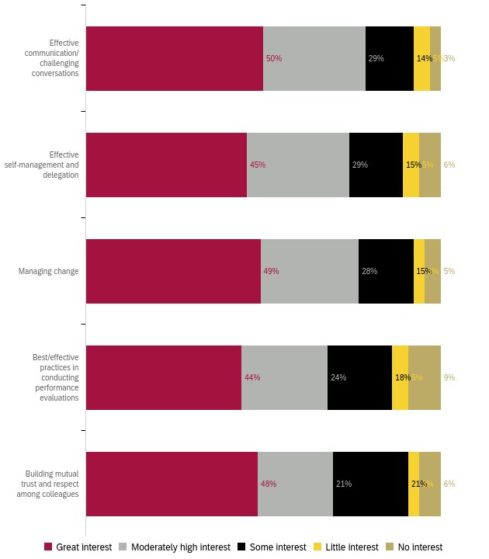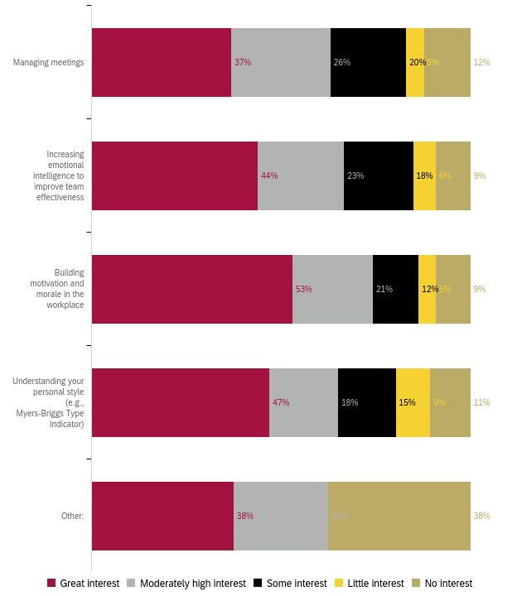

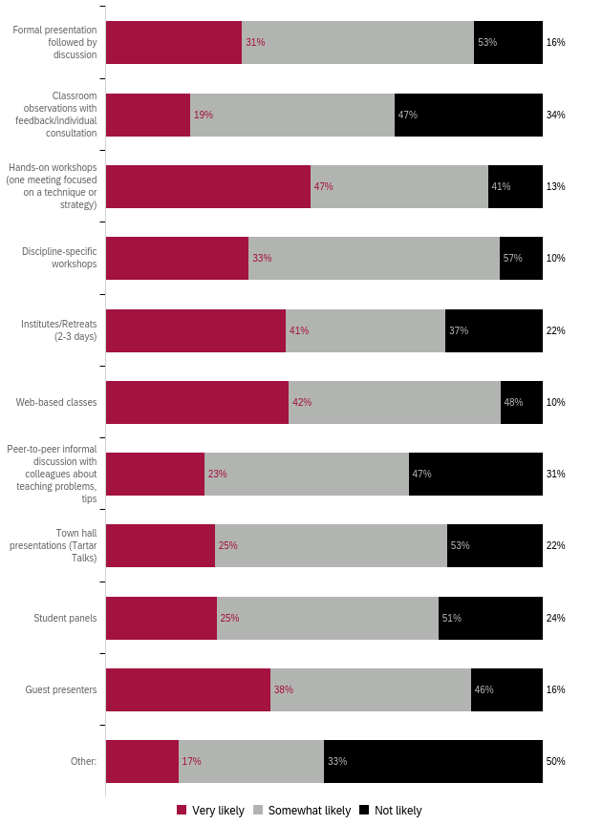
Preferred Professional Development Format
Preferred Format: Ranked 1 (first) to 5 (last)
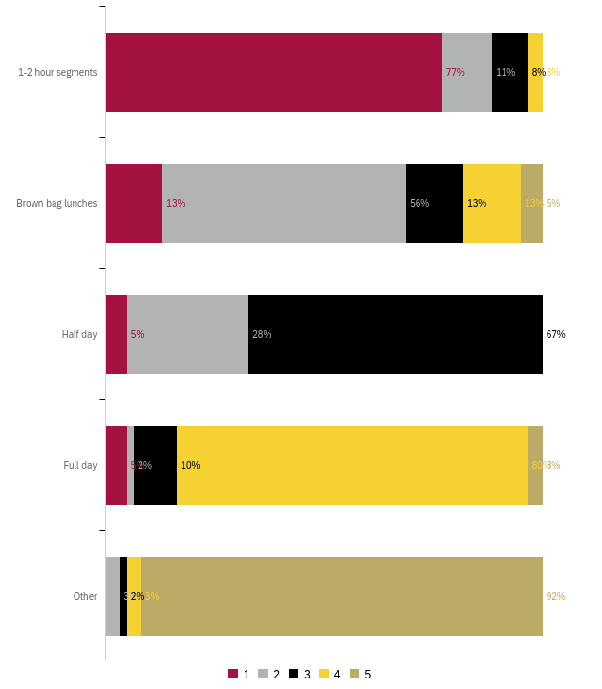
Preferred Day for Training
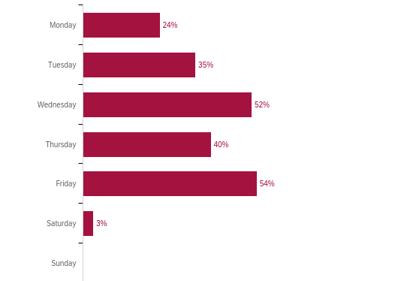

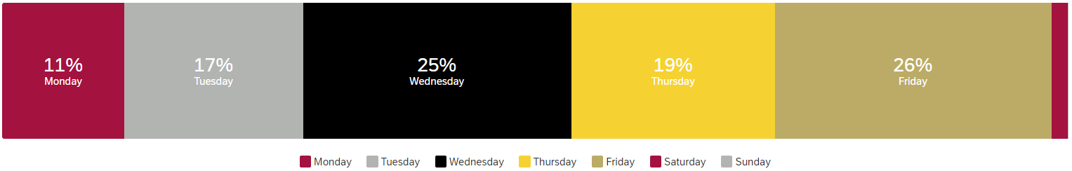

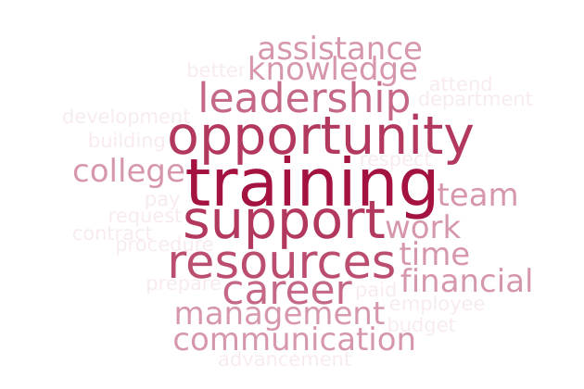
What do you need to enhance your career?

Summary:
The major themes of the comments (42) were regarding:
- Information regarding career opportunities, including advanced degrees
- Software and technology training including Banner, OMNI, and Outlook
- Respect, appreciation, and trust from leadership
- Living wages/COLA
Other concerns included campus procedure training (room reservations, requisitions, etc.), career training and cross-training in other departments, and increased communication and resources
Responses:
- Nothing, N/A (2)
- A larger team, technological resources (e.g., best laptop possible), a good local database system, career training, more remote work days.
- Understanding and knowledge of promotional opportunities and practices.
- Complete training of Banner and a better system to pull MIS reports.
- No resources and training
- Appreciation. A lot of us work hard and cover multiple positions and yet are not really compensated fairly. Bargaining contract is past due and that reflects poorly on Administration, but why should administration care - they get paid livable wages. I don't appreciate that it is so difficult to even get a COLA in our pay. Our benefits package is the pitts. But somehow everyone thinks Professional Development is the answer to everything!
- trust, respect and grace from leadership
- Upper Management Support
- Better tyechnology
- More communication with coworkers and supervisors.
- Financial support.
- Opportunities to shadow in other realms of student services aside from my main role.
- access to financial assistance and courses
- Training on optimizing Outlook
- Learn more about department procedures, for example, requisitions, request for a room, etc.
- Hearing from others career growth and counseling to know what next step are should be. How to prepare to take the next step in our career.
- I would like to gain more knowledge in the area of faculty contracts.
- Decent pay and respect of people when requests are made.
- Proper training on tools and resources to support my role so that I can effectively support students. Open communication and support about getting those tools.
- Having the college to provide programs to prepare employees that have been here for a while to jum start their career to a higher level.
- To be provided release time to attend classes like other employees who were given the opportunity to attend classes.
- opportunity
- Advancement opportunities. Training in college policies and procedures, so they can be applied when needed without delaying the process.
- Advancement Opportunities
- Leadership led direction to increase inter-departmental communication, connection, and discussion on improvements to internal interactions
- Recognition of the skills I possesss
- Staff support. Resources.
- More time!
- "Customer services Team building activities among staff"
- More knowledge of the always changing technology.
- more training on the Campus OMNI website
- Info on what a career path looks like. Resources to carry it out. Specifically, info on pursuing a graduate / terminal degree.
- Safe Zone training to further education around diversity in genders, sexualities, and family structures.
- Administrative assistance, budgeting workshops, performance evaluation workshops, building consensus, growing work development teams, implementing new strategic planning
- Tuition assistance.
- Financial support to attend PD outside of Compton College. For example, ACCCA 201 cost over 2k. I can't afford that. I attended NCCHC and that was over 5k. My VP paid for it and I want to say that ate up her budget. The Liderazgo Leadership Academy with HACU is over 10k. I want to attend these trainings, but they cost money, funds I do not have.
- Support with leadership and management techniques that are practical and coordination with my colleagues to support an inclusive culture.
- Stress and time management skills.
- Networking events
- workshops
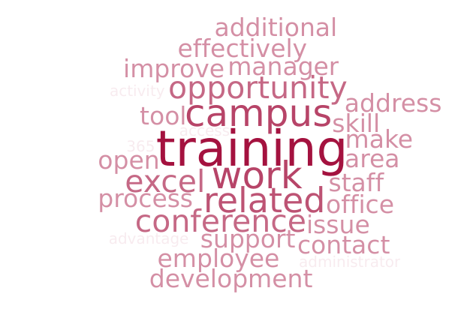
What support or learning opportunity would help you do your job better?

Summary:
An analysis of the 34 responses reveals that most respondents want:
- Training on the processes and timelines of vital offices (HR, Business office)
- Sessions regarding commonly used software: Banner, Microsoft 365, Argos, BEST, CRM Advise, Vision Resource Center, and Outlook
- Information on attending conferences and furthering education
Responses:
- Nothing, N/A (3)
- Attending conferences related to my work.
- Complete training for Microsoft Office and 365.
- More outside training
- Better pay and benefits packages, appropriate COLA, appreciation. More remote work opportunities - maybe as an incentive for those that go above and beyond. Also, an open and safe forum for inter office customer service discussions. Some offices make it very difficult to work with them, yet are vital to our day to day activities. The culture on this campus is terrible and should be addressed, and not through lame PD activities.
- conferences that help us learn what other campuses are doing and how we can improve
- Upper Management Support
- More flexibility to take classes.
- Additional education.
- major related courses
- Training on the curriculum development process translated for non-faculty members.
- Excel training and communication skills.
- I take advantage of online trainings/ and professional development directly related to my area of work.,
- Something that actually applies to my area. However, my area is so specific, it will never be seen as a priority to be catered toward
- Trainings on using CRM Advise/Banner/Website. Having someone to check in, to optimize my work on these tools and periodically address questions or improve use of those tools.
- "Depends on the learning opportunity that will determine what is needed."
- Make training available without assuming, employees already know what processes to follow when they have been internally changed/modify without notification to anyone on campus who are not part of that particular department.
- Leadership skill building and interviewing for manager/director/administrator jobs
- Training or email on Compton College systems used and their main point of contact
- IT
- Staff support. Conference attendance regarding specified work-related issues/topics.
- More staff, more time, access to additional programs and funding.
- Technology training opportunities.
- Many employees lack training in how to effectively use the technological tools available to them. For example, how to write formulas in Excel, how to set up calendar reminders in Outlook, or how to use the Vision Resource Center to earn Flex Credit.
- Excel training. Understanding campus policies and procedures, points of contact, flow of decision-making, etc.
- All of the above.
- A retreat away from campus.
- I think what would be good is to have a manager's book club. I'm not volunteering for it but we should read books like Lencioni's book on the five dysfunctions of a team, etc. Books like this where we can review together, dissect, and analyze. Heck, maybe even invite the authors.
- I would appreciate an open dialogue to discuss real life issues and share resources.
- Knowing when to say no in the workplace.
- How to network effectively
- workshops
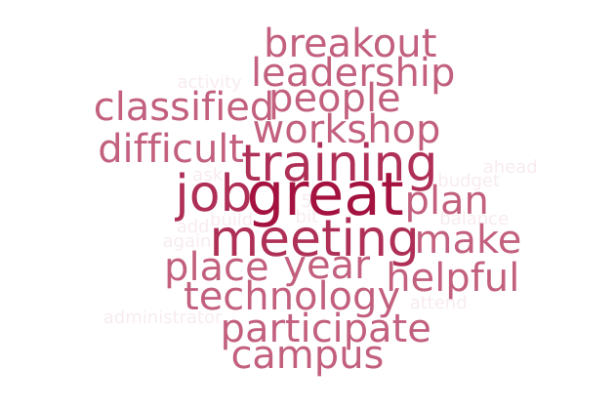
Is there anything else we should know to help build a robust, useful professional development offering?

Summary:
The 29 responses to this question varied widely. One theme that emerged was that of more interactive workshops rather than lectures.
Responses:
- N/A (8)
- Provide useful presentations not like the ones we have had in the past 5 years or so. We already are inclusive and diverse. We do not need any training on this. These presentations/trainings are a bit a slap in the face because we are already, again, inclusive and diverse.
- Great job
- make leadership realize that we need to prioritze professional development for classified preofessionals
- Professional development can be organized in a way that it does not impact one's duties and responsibilities. It should not be imposed but planned for a period, e.g. The fiscal year so it does not interfere with deadlines.
- offer opportunities by paying for industry specific courses
- Making it more interactive and for there to be more participation from folks participating.
- I think more trainings on technology usage would be helpful, related to security measures and troubleshooting.
- It's difficult to take workshops on work-life balance or improving morale when administrators won't participate or allow for those practices to take place. For example, the expectation that people will work extra in an environment where they feel sorely underappreciated and is so unclean.
- I think it is helpful to have a set schedule a semester ahead for others that may plan ahead. I think professional development sessions involving technology should be publicized similarly to the one's publicized by HR. I have missed out on some technology workshops because they were not sent to all employees.
- Topics should be interesting for everyone involved.
- More fun/informal activities throughout the year that could help with stress during stressful/difficult times. For example, the Ice Cream Social is a fun activity and out of the ordinary that invites us to go out and mingle while we wait to be served.
- A budget for classified professionals
- Add Group Q&A in place of Breakout Rooms
- Compton College does a great job providing a variety of professional development.
- Need to start offering more in-person only events. Joining via Zoom has led to many unfocused, disengaged learners. I've been in serveral meetings on Zoom where logged in individuals were not actually present when asked to respond to a question or join a breakout room.
- "Continued focus on diversity in speakers: fewer white men, more women of color, people with disabilities, queer/trans folx, immigrants, etc. Pilar, you do a great job!"
- Less one-way meetings and greater collaboration among professionals.
- Campus wide Customer Service.
- Executive leadership should highlight the PD trainings in our meetings and make them mandatory so we can attend.
- I see a great deal of effort and support by the District in this regard, but it would help to have champions for these efforts strategically across campus to build capacity.
- Appendix A: “Other” Responses
What is your ethnicity “Other” responses:
- Hispanic (2)
- Mexican-American (2)
- Latino
- Hispanic/Latin
- Latino/a

What is your area “Other” responses:
- BUSINESS AND INDUSTRIAL STUDIES
- HR (4)
- Financial aid
- Child Development Center
- CDC
- Assisrant
- N/A
- Anonymous

Non-participation “Other” responses:
- I did participate in PD or N/A (4)
- Workload deadlines, therefore, request will be denied.
- Scheduled events are usually happening outside of my work schedule or at a time when I cannot be away from my area
- It depends on the activities.
- Proctoring a computer assessment

PD for GPD “Other” Responses
- students to have a working computer
- Technology, Curriculum, Resources
- Conflict managament and resolution in the workplace, Management styles: disadvantages, advantages,examples

PD for Technology “Specific Applications” responses:
- Excel (4)
- Adobe
- Schedule zoom meetings, and appointments
- Apple Training
- Use of CRM Advise to communicate with students
- BEST
- Reporting Software

PD for Technology “Other” responses:
- Apple Training
- Faculty Contract/ Course
- How to use VRC Professional Development / Flex features
- calpers website nav

PD for Policies and Procedures “Other” responses:
- Depends on Topic
- Active Shooter / Earthquake preparedness

PD for Wellness “Other” Responses
- Depends on Topic
- AED / Fire Extinguisher use

PD for Work “Other” Responses
- Depends on Topic
- Personal Career Planning - What's the next step up?

PD for Leadership Skills “Other” responses:
- Depends on Topic
- Progressive discipline

PD Format (types of trainings) “Other” responses:
- CANVAS Trainings
- Depends on Topic

“Other” responses listed in Appendix A
“Other” responses listed in Appendix A
“Other” responses listed in Appendix A
“Other” responses listed in Appendix A
“Specific Applications” and “Other” responses listed in Appendix A
“Other” responses listed in Appendix A
“Other” responses listed in Appendix A
“Other” responses listed in Appendix A
“Other” responses listed in Appendix A
“Other” responses listed in Appendix A
“Other” responses listed in Appendix A

